**A Project Report on**

**AUTOMATIC ATTENDANCE TRACING USING IMAGE PROCESSING IN PYTHON**

**Submitted in partial fulfillment of the requirements for the award of the Degree of**

**Bachelor of Technology**

**in**

**Electronics and Communication Engineering**

**By**

**P. MEHAR SRINIVAS CHOWDARI 19A91A0437**

**R. SURESH 19A91A0442**

**N. ADITHYA 19A91A0431**

## Under the Esteemed Supervision of

## Mr. A. Kondababu M.Tech., (Ph.D).

## Assistant Professor



**Department of Electronics and Communication Engineering**

**ADITYA ENGINEERING COLLEGE**

**(An Autonomous Institution)**

(Approved by AICTE, New Delhi, Affiliated to JNTUK Kakinada, Accredited by NAAC with ‘A’ Grade)

Aditya Nagar, ADB Road, Surampalem

**2019 – 2023**

**ADITYA ENGINEERING COLLEGE**

**(An Autonomous Institution)**

(Approved by AICTE, New Delhi, Affiliated to JNTUK Kakinada, Accredited by NAAC with ‘A’ Grade)

Aditya Nagar, ADB Road, Surampalem

**2019 – 2023**

**Department of Electronics and Communication Engineering**



**CERTIFICATE**

This is to certify that the thesis entitled “**Automatic Attendance Tracing using Image Processing in Python”** is being submitted by

**P. MEHAR SRINIVAS CHOWDARI 19A91A0437**

**R. SURESH 19A91A0442**

**N. ADITHYA 19A91A0431**

in partial fulfillment of the requirements for the award of degree of B**.Tech** in Electronics and Communication Engineering from **Jawaharlal Nehru Technological University Kakinada** is a record of bonafide work carried out by them at Aditya Engineering College.

The results embodied in this Project report have not been submitted to any other University or Institute for the award of any degree or diploma.

**PROJECT GUIDE HEAD OF THE DEPARTMENT**

**(Mr. A. Kondababu) (Dr. N. Radha)**

**ACKNOWLEDGEMENT**

We take great pleasure to express our deep sense of gratitude to our project guide **Mr. A. Kondababu,** Assistant Professor, for his valuable guidance during the course of our project work.

We would like to thank **Dr. N. Radha** Head of the Department of Electronics and Communication Engineering for her encouragement.

We would like to express our heart-felt thanks to **Dr. M. Sreenevasa Reddy,** Principal, Aditya Engineering College, Surampalem for providing all the facilities for our project.

Our utmost thanks to all the Faculty members and Non Teaching Staff of the Department of Electronics and Communication Engineering for their support throughout our project work.

Our Family Members and Friends receive our deepest gratitude and love for their support throughout our academic year.

**P. MEHAR SRINIVAS CHOWDARI 19A91A0437**

**R. SURESH 19A91A0442**

**N. ADITHYA 19A91A0431**

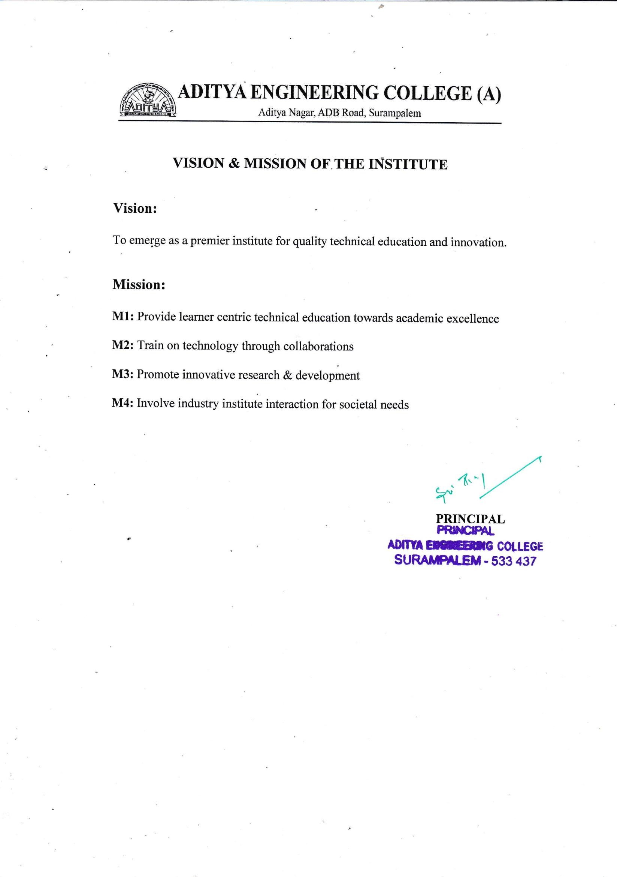



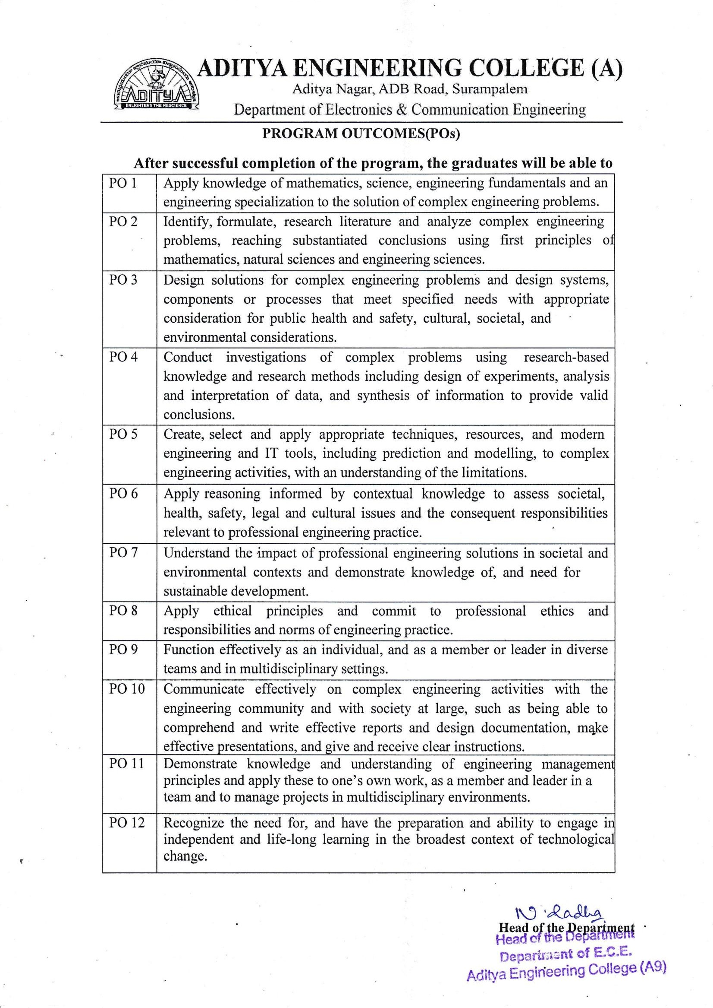

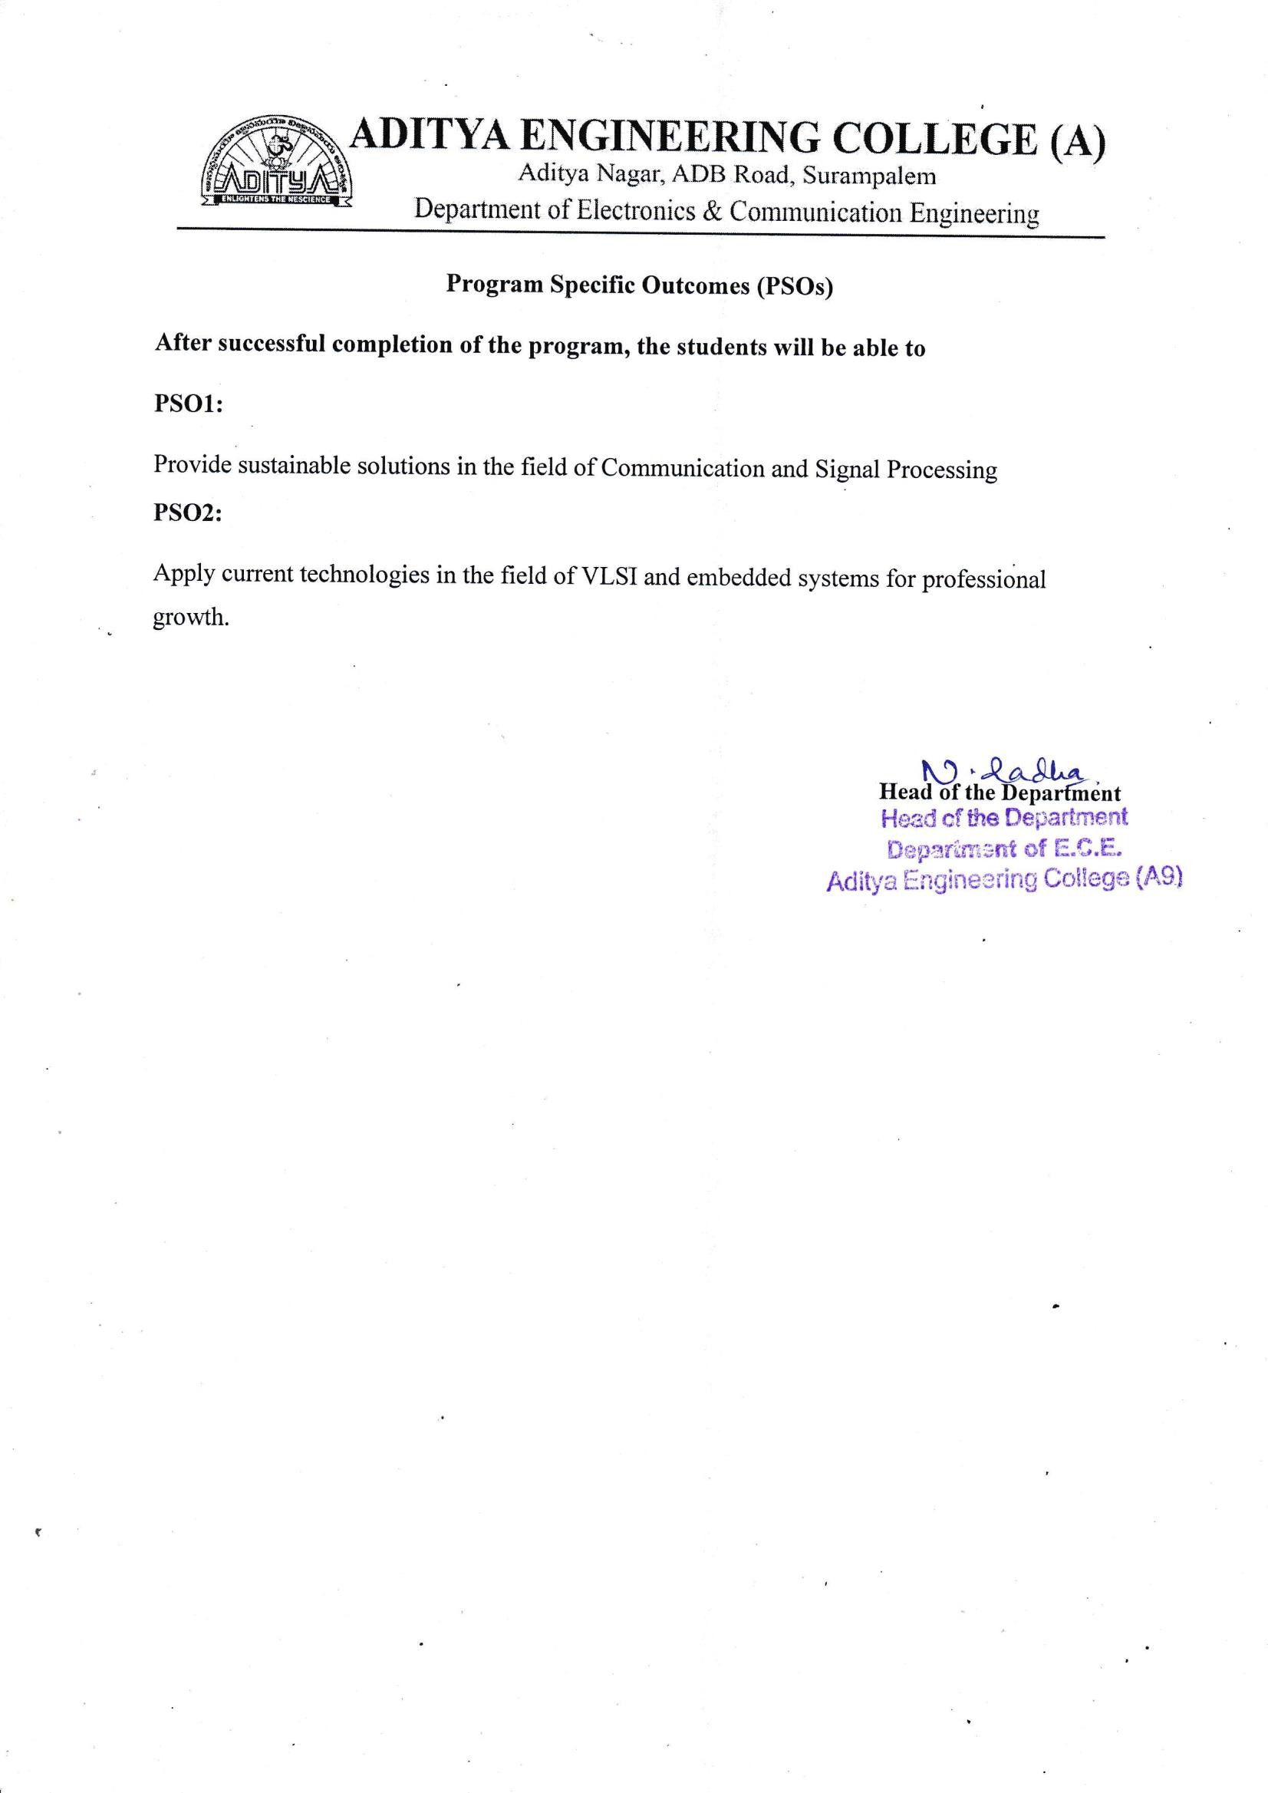

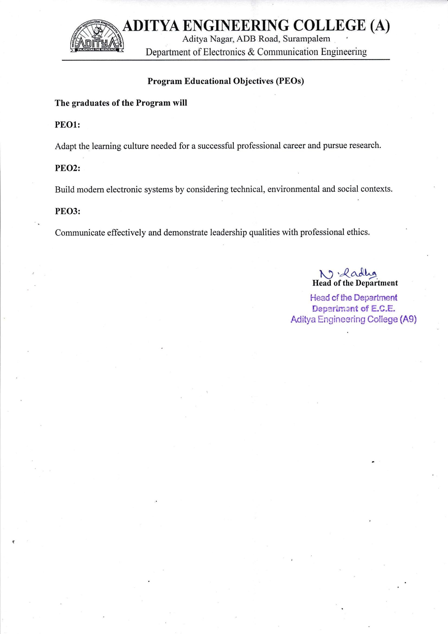

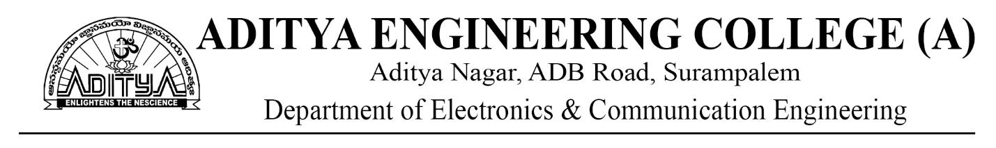

**COURSE OUTCOMES**

**PROJECT PART 1**

Regulation: AR19 L T P C

Course Code: 191EC7P04 0 0 4 2

|  |  |
| --- | --- |
| CO1 | Identify a real life / engineering problem |
| CO2 | Perform extensive investigation with prior knowledge |
| CO3 | Interpret problem formulation and solution through critical thinking |
| CO4 | Develop the work plan, schedule and estimate the cost |
| CO5 | Identify the resources required to initiate project work |

**PROJECT PART 2**

Regulation :AR19 L T P C

Course Code: 191EC8P05 0 0 14 7

|  |  |
| --- | --- |
| CO6 | Apply the domain knowledge to arrive at a framework to solve the problem |
| CO7 | Design solution using research-based knowledge and modern tools and interpret the results |
| CO8 | Assess the obtained solution in the context of engineering framework addressing the societal and environmental concerns adhering to professional ethics |
| CO9 | Demonstrate communication skills effectively to work as a team, for guide interaction and presentations. |
| CO10 | Prepare technical documentation/reports with effective written communication skills |

**CO-PO MAPPING**

|  |  |  |  |  |  |  |  |  |  |  |  |  |  |  |  |
| --- | --- | --- | --- | --- | --- | --- | --- | --- | --- | --- | --- | --- | --- | --- | --- |
| **PROJECT PART-I 191CS7P04** | | | | | | | | | | | | | | |  |
| **CO/PO** | **PO1** | **PO2** | **PO3** | **PO4** | **PO5** | **PO6** | **PO7** | **PO8** | **PO9** | **PO10** | **PO11** | **PO12** | **PSO1** | **PSO2** |  |
| **CO1** | 2 | 3 |  |  |  |  |  |  | 2 |  |  | 1 | 2 |  |  |
| **CO2** | 1 | 2 | 2 | 2 |  |  |  |  | 2 |  |  | 1 | 2 |  |  |
| **CO3** | 1 |  | 3 | 2 | 1 | 2 | 1 |  | 2 |  |  | 1 | 2 |  |  |
| **CO4** | 1 | 1 |  |  |  |  |  |  | 2 | 1 | 3 | 1 | 2 |  |  |
| **CO5** | 1 | 1 | 1 |  | 2 |  |  |  | 1 |  | 3 | 1 | 2 |  |  |
| **PROJECT PART-II 191CS8P05** | | | | | | | | | | | | | | |  |
| **CO/PO** | **PO1** | **PO2** | **PO3** | **PO4** | **PO5** | **PO6** | **PO7** | **PO8** | **PO9** | **PO10** | **PO11** | **PO12** | **PSO1** | **PSO2** |  |
| **CO6** | 3 | 2 | 2 | 2 | 1 |  |  |  | 2 |  | 2 | 3 | 2 |  |  |
| **CO7** | 1 | 2 | 2 |  | 3 | 1 | 1 |  | 2 | 2 | 2 | 2 | 2 |  |  |
| **CO8** | 1 | 1 | 1 | 2 |  | 3 | 3 | 2 | 2 |  | 2 | 2 | 2 |  |  |
| **CO9** | 2 | 1 | 2 | 1 |  |  |  |  | 3 | 3 | 2 | 2 | 2 |  |  |
| **CO10** | 1 | 1 | 1 | 1 | 1 | 1 |  | 3 | 1 | 2 | 1 | 1 | 2 |  |  |



Academic Year: 2022-23

Project Title: **Automatic Attendance Tracing Using Image Processing in Python**

Type of Project: **Societal Based**

Project Guide: Mr A. Kondababu

Project Team: P. Mehar Srinivas Chowdari (19A91A0437)

R. Suresh (19A91A0442)

N. Adithya (19A91A0431)

**ABSTRACT**

There are different prevailing methods to capture person's presence like biometrics to take attendance which is a time-consuming process then why going with biometrics or manual attendance while we have a better alternative using image processing. In the human body, the face is the most crucial factor in identifying each person as it contains many vital details.

In this Project,

The group image is captured first and then from the group image individual faces are identified using face-recognition module and the recognition of faces is done by using KNN(k-nearest neighbours) Algorithm. The capturing of image is continued till the class ends. The attendance will be posted at the end of the class after identification of each and every person. The database can be updated yearly to yield more accurate results.

Automatic Attendance Tracing (AAT) marks individual attendance, if the captured image matches the image in the database i.e., if both images are identical. The proposed algorithm reduces effort and captures day-to-day actions of managing each student and also makes it simple to mark the presence.

**Signature of the Team members**

**LIST OF CONTENTS**

**CONTENTS PAGE NO**

**LIST OF FIGURES i**

**LIST OF TABLES ii**

**CHAPTER – 1 INTRODUCTION 1 – 7**

1.1 Different Types of Attendance Tracing Systems 1

1.2 Problem Statement 4

1.3 Thesis Overview 7

**CHAPTER – 2 BACKGROUND 8 - 24**

2.1Image 8

2.2 Image Processing 10

2.2.1 Components of Image Processing 10

2.2.2 Fundamental Image Processing Steps 12

2.2.3 Applications of Image Processing 14

2.2.4 Benefits of Image Processing 15

2.3 Introduction to Python 16

2.3.1 Python Features 16

2.3.2 Applications of Python 18

2.3.3 Python Architecture and Working 18

2.3.4 Python Constructs 19

2.4 Image Processing in Python 19

2.4.1 Libraries involved in Python 20

**CHAPTER - 3 LITERATURE SURVEY 25 – 39**

3.1 Research Papers 25

3.2 Face Recognition Techniques 30

3.2.1 Appearance based approaches 30

3.2.2 Feature based approaches 35

**CHAPTER - 4 FACE RECOGNITION 40 – 56**

4.1 Face Detection 40

4.1.1 Face detection methods 41

4.1.2 Working of Face Detection 44

4.2 Face Recognition 47

4.2.1 Face Detection Vs Face Recognition 47

4.2.2 Working of Face Recognition 48

4.2.3 Techniques for Face Recognition 49

4.2.4 Use Cases and Applications 53

**CHAPTER – 5 PROPOSED METHODOLOGY 57 – 60**

5.1 Introduction 57

5.2 Working of KNN 58

5.2.1 KNN for Face Recognition 59

5.3 KNN Algorithm Training 59

5.4 Prediction 60

5.5 Trained Algorithm Working 60

**CHAPTER - 6 RESULTS 61 – 66**

**CHAPTER - 7 CONCLUSION AND FUTURE SCOPE 67**

**REFERENCES 68**

**LIST OF FIGURES**

**Figure Number Figure Name Page No**

3.1 Feature vectors are derived using Eigen faces 30

3.2 Example of Six Classes Using LDA 32

3.3 Snapshot of ORL Database 33

3.4 Snapshot of cropped Yale database 34

3.5 Geometrical feature used by Brunelli and Poggio 36

3.6 Left to Right HMM for face recognition 26

3.7 Image is split into shape and shape normalized texture 37

4.1 Different types of Face Detection Methods 41

4.2 Template Matching 42

4.3 Converting RGB image to Grayscale 45

4.4 Haar-like features for face detection 45

4.5 Haar-like features on face 46

4.6 Successfully detect the face in an image 46

4.7 Face detection vs. face recognition 48

4.8 3D model of a human face 51

4.9 Thermal Image of a Human face 52

5.1 Workflow of Algorithm 57

5.2 Basic steps in KNN. 58

6.1 Database Folder 61

6.2 Images of students from database 61

6.3 Testing Image – 1 62

6.4 Testing Image – 2 63

6.5 Testing Image – 3 64

6.6 Testing Image – 4 65

6.7 Attendance in excel sheet 67

**LIST OF TABLES**

**Table Number Table Name Page No**

3.1 ORL Result 34

3.2 Yale Result 35

**CHAPTER – 1**

**INTRODUCTION**

**1.1 DIFFERENT TYPES OF ATTENDANCE TRACKING SYSTEMS**

The methods that are widely used for tracking the employee’s attendance with the aid of technology are as follows:

* Manual Recording (Muster Roll) of In and out time of employees.
* Maintaining the Timesheets (in MS Excel or web-based).
* Mechanized Systems
* Biometrics
* Fingerprint Reader
* Face Reader
* Voice Reader
* Retinal recognition
* Non-Bio-Metric
* Punch Card Reader
* Smart Card Reader
* Proximity Reader

Manual recording:

This is the most commonly used attendance tracking method, even before the age of technology. It is a method of recording the employee’s incoming and outgoing time in a Register or in an MS-Excel or in Book etc. The muster roll register which is usually used for the manual entry of employees is available in stationary stores.

Now, as we have adapted to an automated solution, this method has been outdated. The complexities and requirements are increasing day by day. Manual recording of employee’s incoming and outgoing timing is no longer a simple solution.

Since it is manual recording, it may lead the employees asking for favours to go out and come back often.

Timesheets:

These sheets track the start and end of the tasks given to an employee. Thus, the employer will get a detailed breakup of the tasks accomplished by an employee throughout the total work. This information is used to determine estimation and time management.

These timesheets are widely used online. Some companies provide web-based services for these timesheets. Therefore, the employee’s working hours can be tracked effectively.

The main advantage of tracking the employee’s working time is that first, it will lower the costs. So, the employer can determine the exact time to finish a job/task after considering the timesheet of a similar job/task done by the employee.

Second, the time spent on a particular activity by an individual can be examined and compared. Consequently, an employee’s role can be rearranged based on their work outcome.

Timesheets also provide employee’s productivity in a company. This will also reduce the administrative work to a considerable extent.

Mechanized systems:

When the inputs are provided to the system, it automatically generates a record having in and out timings of employees.

A person need not check every time an employee goes in and out of the organization, as the employee has to swipe/register every entry into the office and exit from the office in a day.

However, an automated system of tracking the employee’s attendance would be more effective than others. Thus, the manual work that needs to be done here is less, and it is more reliable compared to other methods.

The advantages of using this system include:

* Faster processing of data
* Accurate records, minimal supervision Less manual work
* Report generation
* Easy to integrate with a payroll software

Biometrics:

It provides Verification and Identification of the employee to the employer in an organization.

The template is captured either on a smart card or database for the verification purpose of the registered user (employee). As a result, Identification of users is done from the biometric characteristic alone without using smart cards, usernames or ID, etc.

All the records in a database are compared to the template and the closest match score is returned. Therefore, authenticating the closest match within the allowed threshold.

There are two different classes in biometrics:

• Physiological

• Behavioural

Physiological biometrics include capturing and comparing the fingerprints, hand, face, iris, etc., of the person. The most widely used physiological biometrics is Fingerprints.

Behavioural biometrics relates to the behaviour of the person which includes recognizing the voice, signature, and keystrokes, etc.,

Accordingly, biometrics are used in an office for physiological verification of Fingerprints and Retinal recognition.

Access cards/ Swipe cards:

These cards are used to provide access to the user after swiping the card. It stores the data on a magnetic stripe, and it is also called a Magnetic stripe card.

Proximity card readers:

They are contactless integrated circuit devices used for secured access.Proximity cards/ proxy cards have a range of 0-3 inches, and it allows the user to leave the card in a wallet or purse, etc. Therefore, this technology is used in applications such as ID cards, key cards, etc.

A system is not too good or too bad for any organization. Consequently, all the systems have both a positive and a negative side. All the attendance tracking systems generate a record that has the employees’ in and out timings, through which the salary is calculated.

Thus, based on their resources and no. of employees, any method of attendance tracking system can be selected by the company.

**1.2 PROBLEM STATEMENT:**

The current attendance system in place at our organization relies on manual methods for tracking employee attendance. While this system has been in place for many years, it has become increasingly difficult to manage and maintain as our company has grown in size.

The manual attendance system involves employees physically signing in on a paper register each day they are present in the office. This information is then manually entered into a spreadsheet by the HR department at the end of each month. Unfortunately, this system has several limitations and drawbacks that need to be addressed:

* Time-consuming: The process of collecting, collating and entering the attendance data manually is very time-consuming, especially as the company grows and the number of employees increases.
* Prone to errors: The manual process of recording attendance is prone to errors, including missing entries, illegible handwriting, and incorrect data entry. This can lead to inaccurate records and discrepancies.
* Lack of transparency: As the attendance records are maintained manually, it can be difficult for employees to access and review their attendance records. This lack of transparency can lead to disputes and misunderstandings between employees and management.
* Difficult to analyse: The manual attendance system makes it difficult to analyse attendance trends and patterns, which can hinder the HR department's ability to identify and address attendance-related issues.
* Security risks: As the attendance records are maintained on paper, there is a risk of them being lost or stolen. This could compromise the security of sensitive employee information.

The current attendance system used in our organization relies on manual methods such as sign-in sheets, which are prone to errors, time-consuming, and difficult to maintain. This has led to a number of problems, including inaccurate attendance records, delayed payroll processing, and a lack of real-time information about attendance trends. As a result, there is a need to improve the attendance system by implementing a more efficient and reliable method.

Objectives:

To reduce errors in attendance tracking by implementing a more accurate system.

To reduce the time and effort required to manage attendance data.

To provide real-time information on attendance patterns and trends.

To improve payroll processing by ensuring accurate and timely attendance data.

To improve employee satisfaction by providing a more efficient and user-friendly attendance system.

Scope:

The new attendance system will cover all employees within the organization, regardless of their job title or department. It will involve the use of a digital attendance tracking system, which will allow employees to sign in and out using their personal devices or a designated device at the workplace. The system will also provide real-time data on attendance patterns, allowing managers to make informed decisions regarding scheduling and resource allocation.

Constraints:

The implementation of a new attendance system may require additional hardware or software, which may incur costs. There may also be a learning curve for employees who are unfamiliar with digital attendance tracking systems. Furthermore, there may be resistance from employees who are accustomed to the old system and are resistant to change.

Assumptions:

It is assumed that employees have access to personal devices or that the organization can provide designated devices for attendance tracking. It is also assumed that employees will be trained on how to use the new system and that they will be receptive to the change. Additionally, it is assumed that the new attendance system will be compatible with the organization's existing payroll system.

Conclusion:

The current manual attendance system used in our organization has numerous problems that are affecting the accuracy and efficiency of attendance tracking. By implementing a more efficient and reliable attendance system, we can reduce errors, save time, and provide real-time information on attendance patterns. While there may be some constraints and challenges associated with the implementation of the new system, the benefits of the system outweigh the costs.

Overall, the manual attendance system is inefficient and ineffective for a modern workplace. Therefore, it is important for our organization to implement a more streamlined and automated attendance tracking system to improve accuracy, efficiency, and security.

**1.3 THESIS OVERVIEW:**

Chapter 1 discussed about the existing methods and problem statement.

Chapter 2 discussed about Image and Image processing and then about the programming language Python and Image processing in Python.

Chapter 3 reviewed different face recognition techniques using appearance and feature based approaches.

Chapter 4 discussed about how face detection and face recognition works

Proposed methodology discussed in Chapter 5 about the main working algorithm KNN, training and prediction

Chapter 6 results are shown by using different images and excel sheet.

Chapter 7 conclusion and future scope of the project that can be done later for fully automatic implementation.

**CHAPTER -2**

**BACKGROUND**

**2.1 IMAGE:**

In common usage, an image or picture is an artifact that produces the likeness of some subject–usually a physical object or a person. Images may be two dimensional (e.g. a photograph) or three dimensional (e.g. a statue). They are typically produced by optical devices–such as cameras, mirrors, lenses, telescopes, microscopes, etc. and natural objects and phenomena, such as the human eye or water surfaces. The word image is also used in the broader sense of any two-dimensional figures or illustration, e.g. a map, a graph, a pie chart, an abstract painting, etc. In this wider sense, images can also be produced manually (by drawing painting, carving, etc.), by computer graphics technology, or a combination of the two.

A digital image is a representation of a two–dimensional image as a finite set of digital values, called picture elements or pixels. Typically, the pixels are stored in computer memory as a raster image or raster map, a two–dimensional array of small integers. These values are often transmitted or stored in a compressed form. Digital images can be created by a variety of input devices and techniques, such as digital cameras, scanners, coordinate–measuring machines, seismographic profiling, airborne radar, and more.

A pixel is one of the many tiny dots that make up the representation of a picture in a computer‘s memory. Each such information element is not really a dot, nor a square, but an abstract sample. With care, pixels in an image can be reproduced at any size without the appearance of visible dots or squares; but in many contexts, they are reproduced as dots or squares and can be visibly distinct when not fine enough.

The intensity of each pixel is variable; in color systems, each pixel has typically three or four dimensions of variability such and Red, Green and Blue, or Cyan, Magenta, Yellow and Black.

Many display and image-acquisition systems are, for various reasons, not capable of displaying the different colour channels at the same site. This approach is generally resolved by using multiple sub pixels, each of which handles a single colour channel. For example, LCD displays typically divide each pixel into four sub pixels; one red, one green, and two blue. Most digital camera sensors also use sub pixels by using coloured filters.

For systems with sub pixels two different approaches can be taken: the sub pixels can be ignored with pixels being treated as the smallest addressable imaging element, or the sub pixels can be included in rendering calculations, which requires more analysis and processing time, but can produce apparently superior images in some cases. The later approach has been used to increase the apparent resolution of colour displays.

A mega pixel is 1 million pixels, and is usually used to express the resolution capabilities of digital cameras. For example, a camera that can take pictures with a resolution of 2048 x 1536 pixels is commonly said to have 3.1 mega pixels (2048 x 1536=3,145,728). Digital cameras use photo sensitive electronics; either Charge-coupled devices (CCDs) or CMOS sensors, which record brightness levels on a per-pixel basis.

Before we jump into image processing, we need to first understand what exactly constitutes an image. An image is represented by its dimensions (height and width) based on the number of pixels. For example, if the dimensions of an image are 500 x 400 (width x height), the total number of pixels in the image is 200000.

This pixel is a point on the image that takes on a specific shade, opacity or colour. It is usually represented in one of the following:

Grayscale - A pixel is an integer with a value between 0 to 255 (0 is completely black and 255 is completely white).

RGB - A pixel is made up of 3 integers between 0 to 255 (the integers represent the intensity of red, green, and blue).

RGBA - It is an extension of RGB with an added alpha field, which represents the opacity of the image.

Image processing requires fixed sequences of operations that are performed at each pixel of an image. The image processor performs the first sequence of operations on the image, pixel by pixel. Once this is fully done, it will begin to perform the second operation, and so on. The output value of these operations can be computed at any pixel of the image.

**2.2 IMAGE PROCESSING:**

Image processing is the process of transforming an image into a digital form and performing certain operations to get some useful information from it. The image processing system usually treats all images as 2D signals when applying certain predetermined signal processing methods.

Types of Image Processing

There are five main types of image processing:

Visualization - Find objects that are not visible in the image

Recognition - Distinguish or detect objects in the image

Sharpening and restoration - Create an enhanced image from the original image

Pattern recognition - Measure the various patterns around the objects in the image

Retrieval - Browse and search images from a large database of digital images that are similar to the original image

**2.2.1 Components of Image Processing:**

Computer:

A general-purpose computer, which may be anything from a PC to a supercomputer, is used in an image processing system. Sometimes, specifically built computers are utilized in specialized applications to reach a specified degree of performance.

Hardware for Specialized Image Processing:

It comprises the digitizer and hardware that can carry out basic operations, including an Arithmetic Logic Unit (ALU), which can carry out simultaneous arithmetic and logical operations on whole pictures.

Massive Storing:

In applications involving image processing, the skill is essential. The three main types of digital storage for image processing applications are as follows: Three types of storage exist (1) short-term storage, (2) online storage for quick recall (3) archive storage, which is characterized by rare access.

Camera Sensors:

It alludes to perception. The image sensor's primary function is to collect incoming light, transform it into an electrical signal, measure that signal, and then output it to supporting electronics. It consists of a two-dimensional array of light-sensitive components that convert photons into electrons. Images are captured by equipment like digital cameras using image sensors like CCD and CMOS. Two components are often needed on image sensors to collect digital pictures. The first is an actual tool (sensor) that can detect the energy emitted by the object we want to turn into an image. The second is a digitizer, which transforms a physical sensing device's output into digital form.

Image Display: The pictures are shown.

Software: The image processing software comprises specialized modules that carry out particular functions.

Hardcopy Equipment: Laser printers, film cameras, heat-sensitive equipment, inkjet printers, and digital equipment like optical and CDROM discs are just a few examples of the instruments used to record pictures.

Networking: To send visual data through a networked computer, it is a necessary component. The most important factor in picture transmission is bandwidth since image processing applications require vast amounts of data.

**2.2.2 Fundamental Image Processing Steps:**

**Image Acquisition:**

This is the first digital step in image processing. Digital image detection to create specific images, such as a real or real situation internal arrangement of an object. This word is commonly expected to accept processing, congestion, storage, printing, and display of such images. Image acquisition may humble as considering the pre-existing image digital form.

**Image Enhancement:**

Image enhancement is a process of switching digital images to more results suitable for display or multiple image analysis. Because for example, you can turn off sound, sharpen, or turn on image, which makes it easier to identify key features.

**Image Restoration:**

Image Restoration is a function of taking an unethical / noisy image and measuring an unused, new image. Exploitation can occur in many ways such as action blurring, sound and camera focus the purpose of image restoration techniques is to reduce noise and reclaim the loss of decision.

**Colouring Image Processing:**

Colour Image Processing it requires an understanding of the physics of light as well colour vision phycology. The colour of human use details of classification of materials, building materials, food, places and time of day. Colour for the purpose of separation image processing process is used.

Morphological Processing:

Morphological processing is a set of processing operations for morphing images based on their shapes.

**Wavelets Processing and Multiple Solutions:**

When Decorated photo thru atmosphere, clouds, trees, and flowers, you will use a different level brush depending on the size of topographies. Wavelets are likened to those brushes. Wavelets transform is an effective tool for image representation. The wavelet transform allows for the investigation of multiple solutions of the image.

**Image compression:**

Image compression is a type of data useful pressure digital photography, reducing their costs last or spread. Processes can reap visual benefits awareness and asset data image assets to complex effects related to normal pressure strategies.

Segmentation:

Segmentation is one of the most difficult steps of image processing. It involves partitioning an image into its constituent parts or objects.

Representation and Description:

After an image is segmented into regions in the segmentation process, each region is represented and described in a form suitable for further computer processing. Representation deals with the image’s characteristics and regional properties. Description deals with extracting quantitative information that helps differentiate one class of objects from the other.

Recognition:

Recognition assigns a label to an object based on its description.

Blind Deconvolution in Image Processing:

Blind image deconvolution is the challenge of recovering a clear picture from a blurry and noisy one without knowing precisely how the image was blurred, as obtained by an ideal pinhole camera. The unidentified blurring operation might be brought on by defocus, camera movement, scene motion, or other optical defects. A trade-off between exposure duration and aperture setting is necessary for proper photography exposure. The photographer might utilize a big aperture or a lengthy exposure period when the lighting is bad. The first option produces motion blur when the camera moves concerning objects in the scene while the exposure takes place. When using the second option, things farther from the focal plane become out-of-focus blurred. This may lead to blind deconvolution in image processing.

Importance of Phase in Image Processing:

Phase, in a nutshell, contains information about the positions of features. Phase-only and magnitude-only photos cannot be combined to produce the original. To obtain the original, multiply them in the Fourier domain and reverse the transformation. A repeated waveform's phase describes the position or timing of a particular point within a wave cycle. Instead of the actual absolute phases of the signals, the phase difference between waves usually matters.

Ringing Effect in Image Processing:

The unpleasant ringing effect often referred to as the Gibbs phenomenon in mathematical approaches to image processing, is an artifact that appears as rippling ripples close to sharp edges in photos and videos. The loss or distortion of high-frequency information in the image results in this effect.

**2.2.3 Applications of Image Processing:**

Medical Image Retrieval:

Image processing has been extensively used in medical research and has enabled more efficient and accurate treatment plans. For example, it can be used for the early detection of breast cancer using a sophisticated nodule detection algorithm in breast scans. Since medical usage calls for highly trained image processors, these applications require significant implementation and evaluation before they can be accepted for use.

Traffic Sensing Technologies:

In the case of traffic sensors, we use a video image processing system or VIPS. This consists of

a) an image capturing system

b) a telecommunication system and

c) an image processing system.

When capturing video, a VIPS has several detection zones which output an “on” signal whenever a vehicle enters the zone, and then output an “off” signal whenever the vehicle exits the detection zone. These detection zones can be set up for multiple lanes and can be used to sense the traffic in a particular station.

Besides this, it can auto record the license plate of the vehicle, distinguish the type of vehicle, monitor the speed of the driver on the highway and lots more.

Image Reconstruction:

Image processing can be used to recover and fill in the missing or corrupt parts of an image. This involves using image processing systems that have been trained extensively with existing photo datasets to create newer versions of old and damaged photos.

Face Detection:

One of the most common applications of image processing that we use today is face detection. It follows [deep learning algorithms](https://www.simplilearn.com/tutorials/deep-learning-tutorial/deep-learning-algorithm) where the machine is first trained with the specific features of human faces, such as the shape of the face, the distance between the eyes, etc. After teaching the machine these human face features, it will start to accept all objects in an image that resemble a human face. Face detection is a vital tool used in security, biometrics and even filters available on most social media apps these days.

**2.2.4 Benefits of Image Processing:**

The implementation of image processing techniques has had a massive impact on many tech organizations. Here are some of the most useful benefits of image processing, regardless of the field of operation:

* The digital image can be made available in any desired format (improved image, X-Ray, photo negative, etc)
* It helps to improve images for human interpretation
* Information can be processed and extracted from images for machine interpretation
* The pixels in the image can be manipulated to any desired density and contrast
* Images can be stored and retrieved easily
* It allows for easy electronic transmission of images to third-party providers

**2.3 INTRODUCTION TO PYTHON:**

Python is a General-Purpose object-oriented programming language, which means that it can model real-world entities. It is also dynamically typed because it carries out type-checking at runtime.

It does so to make sure that the type of construct matches what we expect it to be.

The distinctive feature of Python is that it is an interpreted language.

Python was conceived in the late 1980s and was named after the BBC TV show Monty Python’s Flying Circus.

Guido van Rossum started implementing Python at CWI in the Netherlands in December of 1989.

This was a successor to the ABC programming language which was capable of exception handling and interfacing with the Amoeba operating system.

On October 16 of 2000, Python 2.0 released with many new features.

Then Python 3.0 was released on December 3, 2008.

**2.3.1 Python Features:**

Let us now see various features of Python that make it so powerful and popular

**a) Easy**

Python is very easy to learn and understand; any beginner can learn Python easily. When writing code in Python, you need fewer lines of code compared to languages like Java.

**b) Interpreted**

It is interpreted(executed) line by line. This makes it easy to test and debug.

**c) Object Oriented**

The Python programming language supports classes and objects and hence it is object-oriented.

**d) Free and Open Source**

The language and its source code are available to the public for free; there is no need to buy a costly license.

**e) Portable**

Since Python is open-source, you can run it on Windows, Mac, Linux or any other platform. Your programs will work without any need to change it for every machine.

**f) GUI Programming**

You can use it to develop a GUI (Graphical User Interface). One way to do this is through **Tkinter**.

**g) Large Python Library**

Python provides you with a large standard library. You can use it to implement a variety of functions without the need to reinvent the wheel every time. Just pick the code you need and continue.

**2.3.2 Applications of Python:**

Python is easy to pick-up even if you come from a non-programming background. You can look at the code and tell what’s going on.

**Talking of Python applications**, some of the cool things that you can do are –

* Build a website using Python
* Develop a game in Python
* Perform Computer Vision (Facilities like face-detection and colour-detection)
* Implement Machine Learning (Give a computer the ability to learn)
* Enable Robotics with Python
* Perform Web Scraping (Harvest data from websites)
* Perform Data Analysis using Python
* Automate a web browser
* Perform Scripting in Python
* Perform Scientific Computing using Python
* Build Artificial Intelligence

**2.3.3 Python Architecture and Working:**

Let’s now talk about Python architecture and its usual flow –

**a) Parser**

It uses the source code to generate an abstract syntax tree.

**b) Compiler**

It turns the abstract syntax tree into Python bytecode.

**c) Interpreter**

It executes the code line by line in a REPL (Read-Evaluate-Print-Loop) fashion.

**2.3.4 Python Constructs:**

a) Functions in Python

A **function in Python** is a collection of statements grouped under a name. You can use it whenever you want to execute all those statements at a time.

You can call it wherever you want and as many times as you want in a program. A function may return a value.

b) Classes in Python

As we discussed earlier, Python is an object-oriented language. It supports classes and objects.

A class is an abstract data type. In other words, it is a blueprint for an object of a certain kind. It holds no values.

An object is a real-world entity and an instance of a class.

c) Modules in Python

Python module is a collection of related classes and functions.

We have [modules](https://docs.python.org/3/tutorial/modules.html) for mathematical calculations, string manipulations, web programming, and many more.

d) Packages in Python

**Python package** is a collection of related modules. You can either import a [package](https://pypi.org/) or create your own.

Python has a lot of other constructs. These include control structures, functions, exceptions, etc.

**2.4 IMAGE PROCESSING IN PYTHON**

Image processing is a way to convert an image to a digital aspect and perform certain functions on it, in order to get an enhanced image or extract other useful information from it. It is a type of signal time when the input is an image, such as a video frame or image and output can be an image or features associated with that image. Usually, the [AWS Image Processing](https://www.mygreatlearning.com/academy/learn-for-free/courses/aws-image-processing?gl_blog_id=36358) system includes treating images as two equal symbols while using the set methods used.

It is one of the fastest growing technologies today, with its use in various business sectors. Graphic Design forms the core of the research space within the engineering and computer science industry as well.

Image Processing basically involves the following three steps.

1. Importing an image with an optical scanner or digital photography.
2. Analysis and image management including data compression and image enhancement and visual detection patterns such as satellite imagery.
3. It produces the final stage where the result can be changed to an image or report based on image analysis.

Image processing is a way by which an individual can enhance the quality of an image or gather alerting insights from an image and feed it to an algorithm to predict the later things.

**2.4.1 Libraries involved in Image Processing:**

The following libraries are involved in performing Image processing in python;

* Scikit-image
* OpenCV
* Mahotas
* SimplelTK
* SciPy
* Pillow
* Matplotlib

Scikit-image is an open-source Python package run by the same NumPy members. It uses algorithms and resources for research, academic and industrial use. It is a simple and straightforward library, even for newcomers to Python’s ecosystem. The code is high quality, reviewed by peers, and written by a working community of volunteers.

Python provides lots of libraries for image processing, including −

OpenCV − Image processing library mainly focused on real-time computer vision with application in wide-range of areas like 2D and 3D feature toolkits, facial & gesture recognition, Human-computer interaction, Mobile robotics, Object identification and others.

Numpy and Scipy libraries − For image manipulation and processing.

Sckikit − Provides lots of algorithms for image processing.

Python Imaging Library (PIL) − To perform basic operations on images like create thumbnails, resize, rotation, convert between different file formats etc.

OpenCV-Python:

OpenCV-Python is a library of Python bindings designed to solve computer vision problems.

Python is a general-purpose programming language started by Guido van Rossum that became very popular very quickly, mainly because of its simplicity and code readability. It enables the programmer to express ideas in fewer lines of code without reducing readability.

Compared to languages like C/C++, Python is slower. That said, Python can be easily extended with C/C++, which allows us to write computationally intensive code in C/C++ and create Python wrappers that can be used as Python modules. This gives us two advantages: first, the code is as fast as the original C/C++ code (since it is the actual C++ code working in background) and second, it easier to code in Python than C/C++. OpenCV-Python is a Python wrapper for the original OpenCV C++ implementation.

OpenCV-Python makes use of Numpy, which is a highly optimized library for numerical operations with a MATLAB-style syntax. All the OpenCV array structures are converted to and from Numpy arrays. This also makes it easier to integrate with other libraries that use Numpy such as SciPy and Matplotlib.

Common Image File Formats:

There are numerous image file types out there so it can be hard to know which file type best suits your image needs. Some image types such a TIFF are great for printing while others, like JPG or PNG, are best for web graphics.

The list below outlines some of the more common file types and provides a brief description, how the file is best used, and any special attributes the file may have.

TIFF (.tif, .tiff)

TIFF or Tagged Image File Format are lossless images files meaning that they do not need to compress or lose any image quality or information (although there are options for compression), allowing for very high-quality images but also larger file sizes.

**Compression:**Lossless - no compression. Very high-quality images. **Best For:** High quality prints, professional publications, archival copies **Special Attributes:**Can save transparencies [Learn more about TIFF file types](http://www.fileinfo.com/extension/tif)

Bitmap (.bmp)

BMP or Bitmap Image File is a format developed by Microsoft for Windows. There is no compression or information loss with BMP files which allow images to have very high quality, but also very large file sizes. Due to BMP being a proprietary format, it is generally recommended to use TIFF files.

**Compression:** None

**Best For:** High quality scans, archival copies [Learn more about BMP file types](http://www.fileinfo.com/extension/bmp)

JPEG (.jpg, .jpeg)

JPEG, which stands for Joint Photographic Experts Groups is a “lossy” format meaning that the image is compressed to make a smaller file. The compression does create a loss in quality but this loss is generally not noticeable. JPEG files are very common on the Internet and JPEG is a popular format for digital cameras - making it ideal for web use and non-professional prints.

**Compression:**Lossy-some file information is compressed or lost **Best For:** Web Images, Non-Professional Printing, E-Mail, PowerPoint **Special Attributes:** Can choose amount of compression when saving in image editing programs like Adobe Photoshop or GIMP.

GIF (.gif)

GIF or Graphics Interchange Format files are widely used for web graphics, because they are limited to only 256 colours, can allow for transparency, and can be animated. GIF files are typically small is size and are very portable.

**Compression:**Lossless - compression without loss of quality **Best For:**Web Images **Special Attributes:**Can be Animated, Can Save Transparency [Learn more about GIF file types](http://www.fileinfo.com/extension/gif)

PNG (.png)

PNG or Portable Network Graphics files are a lossless image format originally designed to improve upon and replace the gif format. PNG files are able to handle up to 16 million colours, unlike the 256 colours supported by GIF.

**Compression:**  Lossless - compression without loss of quality **Best For:**Web Images **Special Attributes:** Save Transparency [Learn more about PNG file types](http://www.fileinfo.com/extension/png)

EPS (.eps)

An EPS or Encapsulated PostScript file is a common vector file type. EPS files can be opened in many illustration applications such as Adobe Illustrator or CorelDRAW.

**Compression:** None - uses vector information **Best For:** Vector artwork, illustrations **Special Attributes:**Saves vector information [Learn more about EPS file types](http://www.fileinfo.com/extension/eps)

RAW Image Files (.raw, .cr2, .nef, .orf, .sr2, and more)

RAW images are images that are unprocessed that have been created by a camera or scanner. Many digital SLR cameras can shoot in RAW, whether it be a .raw, .cr2, or .nef. These RAW images are the equivalent of a digital negative, meaning that they hold a lot of image information, but still need to be processed in an editor such as Adobe Photoshop or Lightroom.

**Compression:** None

**Best For:**Photography **Special Attributes:** Saves metadata, unprocessed, lots of information [Learn more about RAW file types](http://fileinfo.com/extension/raw)

**CHAPTER -3**

**LITERATURE SURVEY**

**3.1 RESEARCH PAPERS:**

Real-Time Smart Attendance System using Face Recognition Technique by authors Shreyak Sawhney, Karan Kacker ,Samyak Jain, Shailendra Narayan Singh and Rakesh Garg. Attendance marking using image processing. Uses CNN (Convolutional Neural Network) for driving the core to mark attendance. Overcomes the chances of proxies and fake attendance. Accuracy is less due to false detection. The image is captured once or twice that may lead to missing attendance marking.

The facial detection model proposed by Kruti Goyal and others, is a facial detection model which is built using different types of algorithms like AdaBoost, Haar Cascades. This model uses MATLAB and OpenCV for its implementation. Extraction of facial features is done as a localization of the face which is performed using pattern recognition.

Abhishek Jha and others proceeded further to a superior system for the recognition process by utilizing statistical methods PCA and LDA in addition to likewise comparing the picture taken and the saved images for marking the attendance. They suggested to the extensive and blunder inclined procedure of participation making which whenever bargained may influence the understudy definitely. They proposed a framework for figuring the pictures in a specific procedure with the goal that matches scoring should be possible. While it very well may be accomplished by utilizing certain calculations, like color detection, PCA and LDA. They made many extractions of facial features from the picture for instance framework of face, nose, and eyes and so on. The PDA and LDA make use of the Eigen Values for students’ attendance to be marked accurately.

Face recognition-based mobile automatic classroom attendance management system: by Authors R. Samet, Muhammed Tanriverdi Published in 2017, proposed three solutions, each of which includes a variety of mobile-based applications for children; instructors and parents would need to download them to their smartphones in order to track and monitor the real-time attendance process. This advantage of this system was .it’s already tested among students at author’s college or institution and the results obtained were satisfactory but on the other side, this system also has some limitations such as it requires three different kinds of mobile applications which was a major drawback of this system.

Automatic attendance system by face recognition using machine learning In This paper, The Authors Sumeet Kewalramani Shree Kasera Bazar Vidya Niketan, published in Oct 2018.it proposed a system that is high usability and it comes with a proxy removal technique which makes the system perfect it is the most promising alternative of fingerprint scanner which consumes time this system works on an algorithm that is a combination of HVS and RGB algorithm. It is more efficient when it takes a single face for recognition, when it takes multiple faces as an input in a single time then sometimes it gives false detection. The facial recognition attendance system is a very efficient way and great tool for taking offline attendance .it is a very portable system we can access it from anywhere by computer or phone. With the help of pure software, approach proxies are completely avoided in this system. It’ll Reduce the amount of labour, time, and resources (such as paper) required and pen for taking manual attendance it’ll already create the list of students with their subjects which very continent for teachers.

Face Recognition and RFID Verified Attendance System proposed by Md. Sajid Akbar, Pronob Sarker, Ahmad Tamim Mansoor is design and implementation of the Attendance System based on Face Recognition and Verification by RFID which the was aim and objective of the paper at the beginning ends with a success as both part works as desired. There it goes without any saying that our proposed model has the potential to overcome the manual attendance system because it’s efficient and convenient. Our model is more user friendly and it provides the most accurate and organized data. And with just some few modification we can use our system in any secured facilities

Priyanka Wagh and others discussed about the various face recognition techniques like Principle Component Analysis (PCA), Eigen face, Support Vector Machines (SVM) and Neural Networks and compared them based on their success rate. The authors also wrote about system architecture, stepby-step methodology and supported it with its algorithm. They have also provided a mathematical model using mathematical concepts and language.

Attendance monitoring in classroom using smartphone & Wi-Fi fingerprinting by Anand S, Kamal Bijlani, Sheeja Suresh and Praphul P discussed Academic performance is directly affected by student attendance during the lecture hours. There are existing manual and automated attendance tracking systems that work to ensure that students attend the lectures without fail. However, the practical implementation of most automated systems have drawbacks such as high monetary cost, the need to install specialized hardware, and proneness to fake or proxy attendance. To address this, we propose a novel attendance marking system with which students may mark attendance using their smartphones. While applying facial recognition via the smartphone's front camera to determine the student's identity, the system also makes use of the campus Wi-Fi network to determine the student’s location. The proposed system does not require high monetary cost or specialized hardware and yet incorporates adequate fool proof measures to counter fake or proxy attendance. Experimental studies with our system show that fingerprinting, which is the technique used here to determine indoor location, can achieve very good positioning accuracy even in classroom environments, where signal interference is usually very high.

Saeed Mian Qaisar, Abdulhamit Subasi from R. F. Kurdi College of Engineering, Effat University, Jeddah, KSA discussed An Event Driven Attendance Tracker, In current era the Internet of Things (IoT) is becoming an important part of our daily life. It is employed in a variety of applications like smart cities, smart agriculture, smart wearable’s etc. The aim of this project is to use the IoT with an intelligent event-driven system in order to devise an effective quasi real-time attendance tracker. The idea is to keep the whole system in the standby mode except for the low power motion sensor. On the detection of an event, when a person enters and originates a motion, the front-end embedded processor is alarmed. The attendance log remains globally available via the cloud and can be accessed anytime. The system design flow is described. Its parameters are adjusted in order to achieve the effective performance. The proposed system operation is tested with an experimental setup. Results have confirmed a proper system functionality.

An Image Acquisition Method for Face Recognition and Implementation of an Automatic Attendance System for Events discussed by Luis Fung-Lung, Mikael Nycander-Barua and Pedro Shiguihara-Juarez as Facial image acquisition systems produce low quality face images. This happens because the imaging conditions like illumination, occlusion or noise might change among images. To achieve optimal images, we proposed an image acquisition method for face recognition. Then, with this method, it was created the Smart Event Faces Database that contains video frames from videos taken by smartphones and Raspberry Pi. Also, it was measured the accuracy for face recognition and execution time for the Smart Event Faces Database using ResNet 34 for feature extraction and the next classifiers: K-Nearest Neighbors, Naive Bayes, Random Forest, Multi-Layer Perceptron, Decision Tree, Adaboost and Support Vector Machine. Additionally, we compared these classifiers to show which was effective for the dataset in terms of accuracy and execution time. Then, we used the Smart Event Faces Database to create an automatic attendance system for events using Raspberry Pi, ResNet-34 and K-Nearest Neighbors classifier. The results achieved in the Smart Event Faces Database showed that K-Nearest Neighbors and Support Vector Machine had the best results with more than 0.96 of accuracy for face recognition and less than 1.5 seconds respectively of execution time. The automatic attendance system had an accuracy for face recognition of 0.94 and 0.5 seconds approximately per frame in execution time for 19 persons in 2 events.

Attendance Management System Based on Face Recognition Using Haar-Cascade by Ashish Yadav, Aman Sharma and Sudeept Singh Yadav from SCSE Galgotias University Greater Noida, India discussed Smart Attendance with Real-Time Face Recognition is a practical option for managing student attendance systems on a daily basis. An attendance system based on facial recognitionis a method of identifying people by their faces.The regularity of student attendance is now a major problem for educational institutions. This is primarily owing to the fact that a student's total academic success is influenced by their attendance at the institute. Calling out the roll call or having students sign a piece of paper are the two most common methods of recording attendance. Face biometrics based on a high-definition monitor are used to recognise students' faces for the purpose of taking attendance.They were both more difficult and time-consuming. video, as well as other forms of information technology. Faces will be found by a computer system in my face recognition project. can distinguish human faces in photos or videos acquired by a surveillance system quickly and precisely camera. For enhancing the performance of face recognition, a variety of algorithms and strategies have been developed. As a result, a computer-based student attendance management system is required, which will assist instructors in automatically keeping attendance data.

Automated Attendance System in the Classroom Using Artificial Intelligence and Internet of Things Technology proposed by Duy Dieu NGUYEN, Xuan Huy NGUYEN, The Tung THAN and Minh Son NGUYEN from University of Information Technology – VNUHCM Ho Chi Minh, Vietnam discussed Computer vision is recently developing and applying in the utility apps serving people, facial recognition is one of its applications. Although the accuracy of the facial recognition is less than when compared to fingerprint recognition, iris recognition and Radio Frequency Identification (RFID) card recognition. But it is still widely used because the recognition process does not contact the device. With the advantage of the facial recognition method, we propose an automated attendance solution which uses embedded device integrated Artificial Intelligence technology (AI) and Internet of Things technology (IoT) in the smart classrooms. The highlight of the system is the ability to take attendance automatically and continuously throughout the learning period. When the students enter the class, the management department and the parents can know the student’s participation status by viewing the report in the real-time system. The system which is an embedded system-based application solution has low operating costs and rapid deployment.

**3.2 FACE RECOGNITION TECHNIQUES:**

**3.2.1 Appearance Based Approaches:**

The Eigen Face Method:

Firstly Kirby and Sirvoich demonstrated Eigenfaces method for recognition. Pentland and Turk made improvements on this research by employing Eigenfaces method based on Principle Component Analysis for the same reason. PCA is a Karhumen-Loeve transformation. PCA is a realized linear dimensionality reduction method used to determine a set of mutually orthogonal basis functions and as shown in Fig 3.1

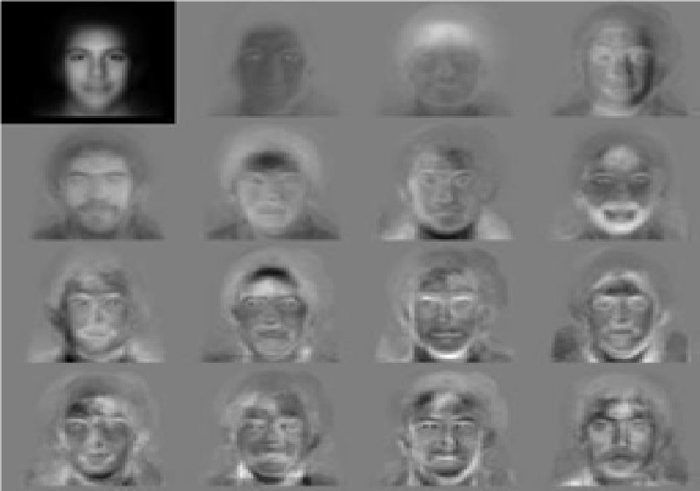

Fig 3.1: Feature vectors are derived using Eigen faces

It uses the vanguard eigenvectors of the sample covariance matrix to characterize the lower dimensional. It is used to reduce dimension of image matrix. Ex: If a face image is represented in g dimensional space, PCA aims to obtain an h dimensional sub space using linear transforms, which answers maximum variance in g dimensional space and g is too big according to h. Subtracting the normalized training images from the calculated mean images thus mean centered images are calculated. If w is mean centered training image matrix Wi(i=1,2,........,L) and l is the number of training images, matrix d is calculated from as in equation 1

D = $WW^{T}$ (1)

To reduce the size of covariance matrix D, we can use D = WTW instead. Eigenvectors ei and eigen values λi are obtained from covariance matrix.

$Z_{i}$ = $E^{T}w_{i}$ ( $ⅈ$ = 1, 2, ...., L) (2)

In the equation 2, Zi represents the new feature vector of lower dimensional space. Negative aspect of this method, it tries to max inter and intra class scattering. Inter class scattering is good for classification where intra scattering is not. If there is variance illumination, increases intra class scattering very high, even classes seems stained.

The Fisher Face Method:

Belhumeur introduced the Fisher Face method in 1997, a derivative of Fishers Linear Discriminant (FLD) which has linear discriminant analysis (LDA) to gain the vast discriminant structures. Both PCA and LDA which are used to produce a subspace projection matrix is similar to eigen face and Fisher face methods. LDA describes a pair of projection vectors which form the maximum between-class scatter and minimum in the class scatter matrix concurrently produces lower error when compared to Eigen face method. Six different classes using LDA with large variances within classes, but little variance within classes are shown in Fig 3.2.

Kernel FLD is capable of extracting the most distinct features in the feature space, which is common to the nonlinear features in the reference input space and shows better results when compare to the conventional Fisher face which is established on second order statistics of an image-set without considering the high order statistical dependencies. Few of the modern LDA-based algorithms include: Direct LDA constructing the image scatter matrix obtained from a normal two dimensional image and it is capable of resolving small sample size problem. Further, to resolve the same problem Dual-Space LDA algorithm requires full discriminative information of face. Both LDA and weighted pair wise Fisher criteria privileges are used together by Direct-Weighted LDA. Block LDA algorithm segments the entire image into several blocks and structures each block as a row vector. Linear discrimination analysis is performed on the row vectors for block which from the two-dimensional matrices. The K-Nearest Neighbour approach (KNN) and the Nearest Mean approach (NM) are the two approaches fused using LDA and PCA, was done on the AT&T and Yale datasets.

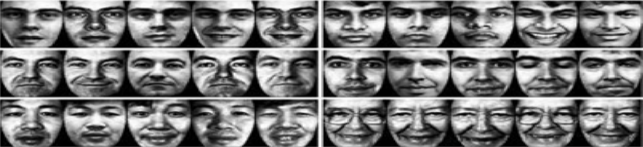

Fig 3.2: Example of Six Classes Using LDA

Fisher face or Linear Discriminant Analysis (LDA) aims to increase inter class differences and are not used to increase data representation.

$S_{w}=\sum_{j=1}^{R}{\sum_{j=1}^{M}{{\left(x_{i}^{j}-μ_{j}\right)\left(x_{i}^{j}-μ_{j}\right)}^{T}}}$ (3)

$S_{b}=\sum_{j=1}^{R}{{\left(μ_{j}-μ\right)\left(μ_{j}-μ\right)}^{T}}$ (4)

Above are intra class (Equation 3) and inter class (Equation 4) scatter matrices respectively. The indices, i is image number, j is class. j is the mean of class j , and is mean of all classes. Mj shows the number images in class j, and R is the number of classes. Sb is maximized while Sw is minimized for the classification to be done. Intrinsic factors are independent of the observer and represents the objective of the face. Further it can be divided into intrapersonal and interpersonal.

Support Vector Machines:

To improve the classification performance of the PCA and LDA subspace features, support vector [SVM] machines came into existence, Supervised learning techniques are used to train SVM generally. In estimating the Optimal Separating Hyper plane (OSH) a set of images is used for training SVM. Bringing down the risk of misclassification among two classes of image in some feature space. Guo et al applied this technique for face recognition. He applied binary tree classification techniques where a face image is continuously grouped as belonging to one of two classes. A binary tree structure is applied until the two classes denote individual subjects and a final classification decision can be arrived. SVM has be opted for face recognition by some other researchers to attain good results.

Performance Comparison & Experimental result for appearance based approaches:

Two sets of experiments are shown to examine the performance of individual algorithms. For a given sample of n images in a class, a classifier is trained using (n-1) images in that class and tested on the remaining single case. This test repeats n times until each time training a classifier with leaving-one-out. This is how all images are used for training and testing to attain good result.

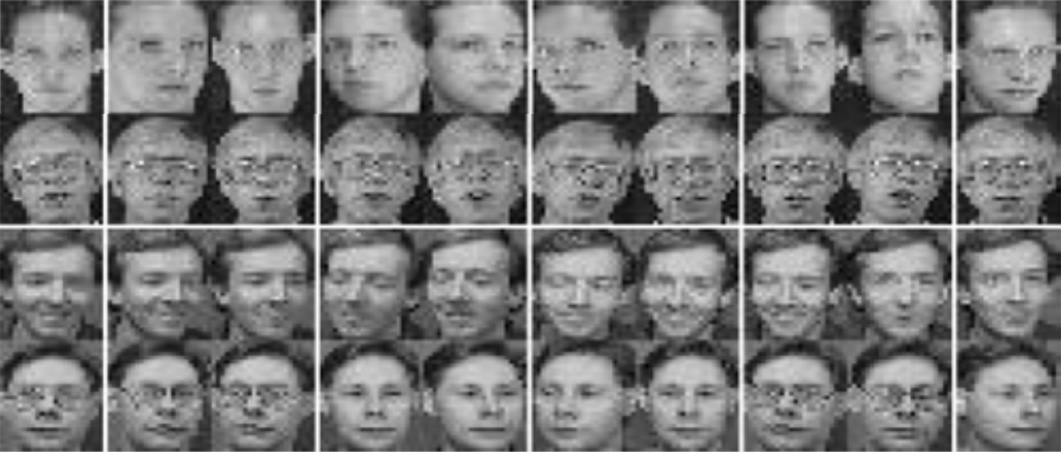

Fig 3.3: Snapshot of ORL Database

AT & T Laboratories Cambridge is the first to perform experiments on the ORL face databases. These images are in grayscale with a resolutions of 92 x 112 pixels containing 400 images, including 40 distinct people, each with 10 images that are different in position, rotation, scale and expressions. The images are shot under constant light exposure. Fig 3.3 shows a snapshot of 4 individual from the ORL results

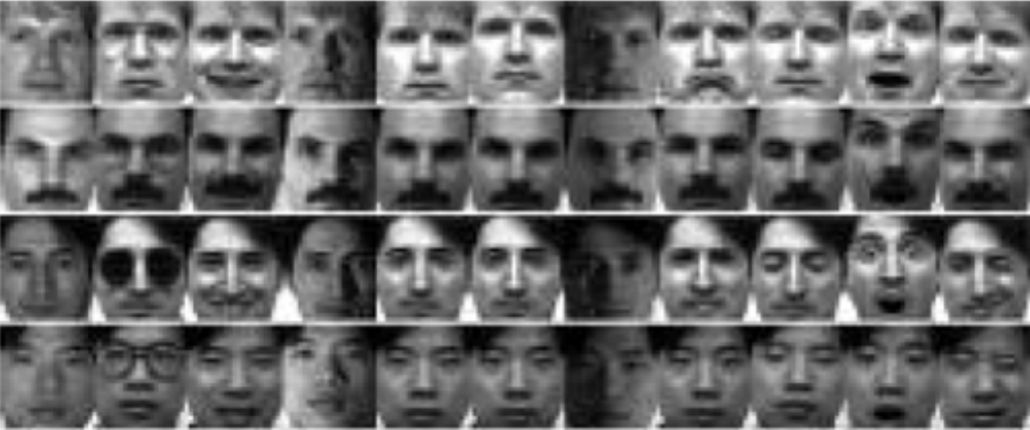

Fig 3.4: Snapshot of cropped Yale database

Table 3.1: ORL Result

|  |  |  |  |
| --- | --- | --- | --- |
| Image set | Eigen | Fisher | SVM |
| 1 | 92.5% | 100.0% | 95.0% |
| 2 | 85.0% | 100.0% | 100% |
| 3 | 87.5% | 100.0% | 100% |
| 4 | 90.0% | 97.5% | 100% |
| 5 | 85.0% | 100.0% | 100% |
| 6 | 87.5% | 97.5% | 97.5% |
| 7 | 82.5% | 95.0% | 95.0% |
| 8 | 92.5% | 95.0% | 97.5% |
| 9 | 90.0% | 100.0% | 97.5% |
| 10 | 85.5% | 97.5% | 95.0% |
| Average | 87.5% | 98.3% | 97.8% |

Yale Face Database:

Second experiment is performed on Yale face database from Yale University. These images are in gray-scale and have cropped to a resolution of 116 x 136 ppi, has 165 images in group, including 15 discrete people, each with 11 images that differ in both lighting and expression. A snapshot of 4 individuals from the database is how in Fig 3 4. The results of FRCM performed on Yale database to distinguish the 15 people under different conditions is given in the Table 2.

**3.2.2 Feature Based Approaches:**

Face Recognition through Geometric Features:

In the first phase a set of fiducial points are examined in each faces and the geometric facts such as distances between these points are explored and the image closest to the query face is nominated. This process was done by Kanade. who employed the Euclidean distance for correlation between 16 extracted feature vectors constructed on image database of 20 distinct people with 2 imager per person and attained accuracy rate of 75%. Further, Brunelli and Poggio. practiced the same on 35 geometric features from image database of 47 peculiar people with 4 images per person as displayed in Fig 3.5 and attained performance rate of 95%. Most recently, Cox et al. derived 35 facial features from a database comprised 685 images and reportedly achieved a recognition performance rate of 95% on a database of 685 images with one image for each individual.

Table 3.2: Yale Result

|  |  |  |  |
| --- | --- | --- | --- |
| Image Set | Eigen | Fisher | SVM |
| Centerlight | 53.3 | 93.3 | 86.7 |
| Glasses | 80 | 100 | 86.7 |
| Happy | 93.3 | 100 | 100 |
| Left light | 26.7 | 26.7 | 26.7 |
| No glasses | 100 | 100 | 100 |
| Normal | 86.7 | 100 | 100 |
| Right light | 26.7 | 40 | 13.3 |
| Sad | 86.7 | 93.3 | 100 |
| Sleepy | 86.7 | 100 | 100 |
| Surprised | 86.7 | 66.7 | 73.3 |
| Wink | 100 | 100 | 93.3 |

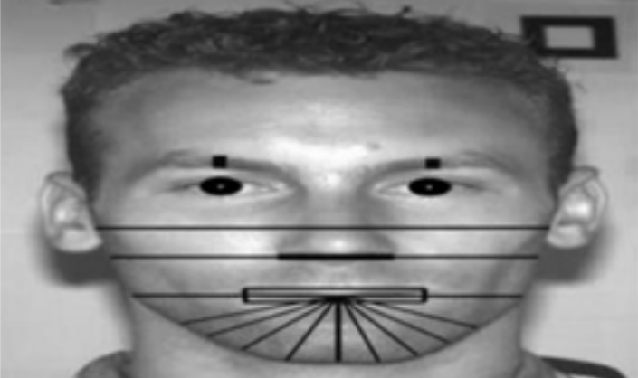

Fig 3.5: Geometrical feature used by Brunelli and Poggio

Hidden Markov Model (Hmm):

The HMM was first presented by Young and Samaira. HMM generally employed on images with variations due to lighting, orientation and facial expression and thus it have more advancements over than the approaches for treating images using HMM, space sequences are considered. This procedure is named as a Hidden Markov Model this is why because the states are invisible, only the output is vivid to the external use. This procedure uses pixel strips to cover all the areas in the without finding the precise locations of facial features. The face arrangements are identified as a continuous of discrete parts. The arrangements of the system should be maintained for e.g., it should start from top to bottom from forehead, eyes, nose, mouth, and chin as in fig 6.

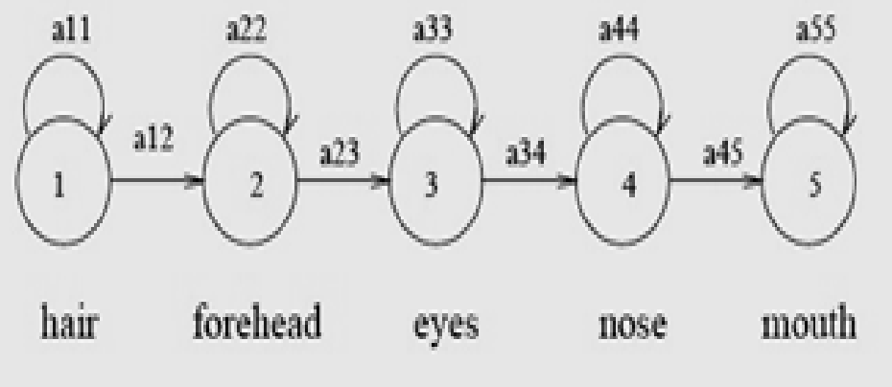

Fig 3.6: Left to Right HMM for face recognition

Active Appearance Model (AAM)-2D Morphable Method:

Faces are highly distinct and able to be deformed. Classifying by pose, expression, lighting, and faces can have various looks in the images. Coots, Taylor, and Edwards. presented Active Appearance Model which is strongly capable of explaining the view of face in set of model parameters. AAM is an integrated statistical model, implemented on the basis of a training set comprising labelled images. The landmark points are pointed as show in Fig 3.7. Model parameters are found to ability matching with the image which brings down the difference between the image and a synthesized model sample projected into the image.

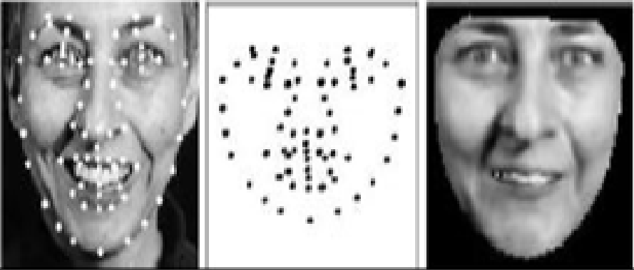

Fig 3.7: image is split into shape and shape normalized texture

3D Morphable Model:

To differentiate the facial variations like illumination, pose etc. 3D morphable model is an effective, strong and versatile representation of human faces and so it is better to represent the face by employing 3D model. High quality frontal and half profile picture are taken first of each subject under ambient lighting conditions to make a 3D model. Later these images are use as reference to the analysis by synthesis loop which results a face mode. Blanz et al. proposed this method based upon a 3D morphable face model in which he tries to find an algorithm to reconstruct the parameters like texture and shape from the single image of a face and encodes them with respect to model parameters. Thus the 3D morphable model provides the full 3D feature information which enables for automatic extraction of facial regions and facial components.

Hybrid Methods:

These methods show better results using both the holistic and feature-based methods to recognize the face. Eigen modules proposed by Pentland et al., which applied both local Eigen features and global Eigen faces and shows much better results than the holistic eigen faces. Penev and Atiek, used a method called Hybrid LFA (Local Feature Analysis). Shape-normalized Flexible appearance technique by lantis et al. which combines component based Face region and components by Huang et al. which combines component based recognition and 3D morphable model for face recognition.

The important phase is to generate 3D face models using 3D morphable model form the three reference images of each person. These images are furnished under variable illumination conditions and pose to populate a large set of synthetic images, are used to train a component-based face recognition system. A Support Vector Machine (SVM) based recognition system is used to decompose the face into a set of components that are interconnected by a flexible geometrical model so that it can keep track for the changes in the head pose leading to changes in the position of the facial components.

Conclusions for Feature based approaches:

Face recognition is a highly challenging task in the domain of image analysis and computer vision that has received an immense deal of attention over the last few decades because of its many applications in vast domains. Few classical face recognition techniques are cited in this paper. In some face database, the methods of SVM and HMM can produce better face recognition results, but they use more complex algorithms. Research has been conducted exorbitantly in this area and immense progress has been attained, notable results have been obtained and present face recognition systems have elevated to a certain measure of maturity when imposed under constrained conditions; however, these methods are far from achieving the ideal of being able to perform adequately in all the various situations that are commonly faced by the applications employing these procedures in practical life. The fundamental goal of researchers in this domain is to enable computers to emulate the human vision system and, as has aptly pointed out by Torres, Strong and coordinated effort between the computer vision, psychophysics and signal processing and neurosciences communities is needed to derive this objective.

**CHAPTER - 4**

**FACE RECOGNITION**

**4.1. FACE DETECTION:**

In past few years, face recognition owned significant consideration and appreciated as one of the most promising applications in the field of image analysis. Face detection can consider a substantial part of face recognition operations. According to its strength to focus computational resources on the section of an image holding a face. The method of face detection in pictures is complicated because of variability present across human faces such as pose, expression, position and orientation, skin colour, the presence of glasses or facial hair, differences in camera gain, lighting conditions, and image resolution.

Object detection is one of the computer technologies, which connected to the image processing and computer vision and it interacts with detecting instances of an object such as human faces, building, tree, car, etc. The primary aim of face detection algorithms is to determine whether there is any face in an image or not.

In recent times, a lot of study work proposed in the field of Face Recognition and Face Detection to make it more advanced and accurate, but it makes a revolution in this field when Viola-Jones comes with its Real-Time Face Detector, which can detect the faces in real-time with high accuracy.

Face Detection is the first and essential step for face recognition, and it is used to detect faces in the images. It is a part of object detection and can use in many areas such as security, biometrics, law enforcement, entertainment, personal safety, etc.

It is used to detect faces in real time for surveillance and tracking of person or objects. It is widely used in cameras to identify multiple appearances in the frame Ex- Mobile cameras and DSLR’s. Facebook is also using face detection algorithm to detect faces in the images and recognise them.

**4.1.1 Face Detection Methods:**

Yan, Kriegman, and Ahuja presented a classification for face detection methods. These methods divided into four categories, and the face detection algorithms could belong to two or more groups. These categories are as follows-

Fig 4.1: Different types of Face Detection Methods

Knowledge-Based:

The knowledge-based method depends on the set of rules, and it is based on human knowledge to detect the faces. Ex- A face must have a nose, eyes, and mouth within certain distances and positions with each other. The big problem with these methods is the difficulty in building an appropriate set of rules. There could be many false positive if the rules were too general or too detailed. This approach alone is insufficient and unable to find many faces in multiple images.

Feature-Based:

The feature-based method is to locate faces by extracting structural features of the face. It is first trained as a classifier and then used to differentiate between facial and non-facial regions. The idea is to overcome the limits of our instinctive knowledge of faces. This approach divided into several steps and even photos with many faces they report a success rate of 94%.

Template Matching:

Template Matching method uses pre-defined or parameterised face templates to locate or detect the faces by the correlation between the templates and input images. Ex- a human face can be divided into eyes, face contour, nose, and mouth. Also, a face model can be built by edges just by using edge detection method. This approach is simple to implement, but it is inadequate for face detection. However, deformable templates have been proposed to deal with these problems.

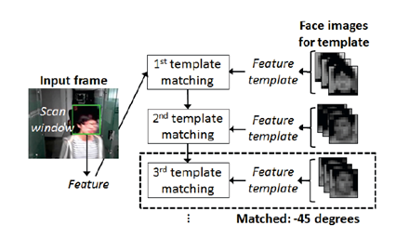

Fig 4.2: Template Matching

Appearance Based:

The appearance-based method depends on a set of delegate training face images to find out face models. The appearance-based approach is better than other ways of performance. In general appearance-based method rely on techniques from statistical analysis and machine learning to find the relevant characteristics of face images. This method also used in feature extraction for face recognition.

The appearance-based model further divided into sub-methods for the use of face detection which are as follows-

Eigenface Based:

Eigenface based algorithm used for Face Recognition, and it is a method for efficiently representing faces using Principal Component Analysis.

Distribution Based:

The algorithms like PCA and Fisher’s Discriminant can be used to define the subspace representing facial patterns. There is a trained classifier, which correctly identifies instances of the target pattern class from the background image patterns.

Neural Networks:

Many detection problems like object detection, face detection, emotion detection, and face recognition, etc. have been faced successfully by Neural Networks.

Support Vector Machine:

**S**upport Vector Machines are linear classifiers that maximise the margin between the decision hyperplane and the examples in the training set. Osuna et al. first applied this classifier to face detection.

Sparse Network of Winnows:

They defined a sparse network of two linear units or target nodes; one represents face patterns and other for the non-face patterns. It is less time consuming and efficient.

Naive Bayes Classifiers:

They computed the probability of a face to be present in the picture by counting the frequency of occurrence of a series of the pattern over the training images. The classifier captured the joint statistics of local appearance and position of the faces.

Hidden Markov Model:

The states of the model would be the facial features, which usually described as strips of pixels. HMM’s commonly used along with other methods to build detection algorithms.

Information Theoretical Approach:

Markov Random Fields (MRF) can use for face pattern and correlated features. The Markov process maximises the discrimination between classes using Kullback-Leibler divergence. Therefore this method can be used in Face Detection.

Inductive Learning:

This approach has been used to detect faces. Algorithms like Quinlan’s C4.5 or Mitchell’s FIND-S used for this purpose.

**4.1.2 Working of Face Detection:**

There are many techniques to detect faces, with the help of these techniques, we can identify faces with higher accuracy. These techniques have an almost same procedure for Face Detection such as OpenCV, Neural Networks, Matlab, etc. The face detection work as to detect multiple faces in an image. Here we work on OpenCV for Face Detection, and there are some steps that how face detection operates, which are as follows-

Firstly the image is imported by providing the location of the image. Then the picture is transformed from RGB to Grayscale because it is easy to detect faces in the grayscale.

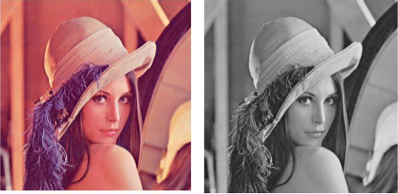

Fig 4.3: Converting RGB image to Grayscale

After that, the image manipulation used, in which the resizing, cropping, blurring and sharpening of the images done if needed. The next step is image segmentation, which is used for contour detection or segments the multiple objects in a single image so that the classifier can quickly detect the objects and faces in the picture.

The next step is to use Haar-Like features algorithm, which is proposed by Voila and Jones for face detection. This algorithm used for finding the location of the human faces in a frame or image. All human faces shares some universal properties of the human face like the eyes region is darker than its neighbour pixels and nose region is brighter than eye region.

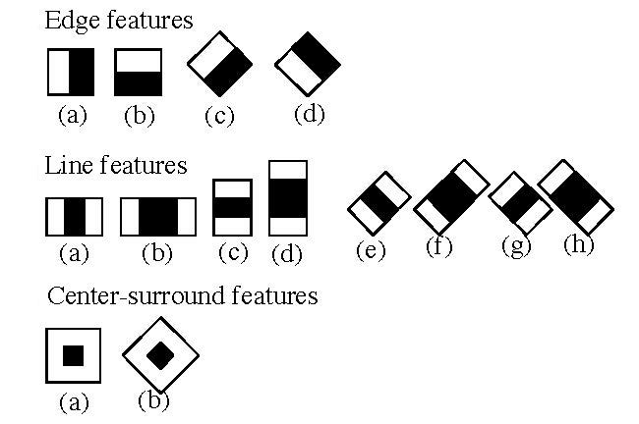

Fig 4.4: Haar-like features for face detection

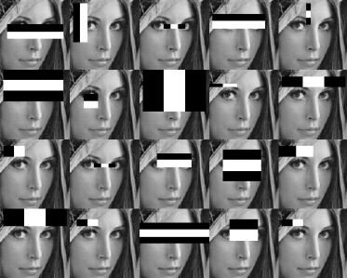

Fig 4.5: Haar-like features on face

The haar-like algorithm is also used for feature selection or feature extraction for an object in an image, with the help of edge detection, line detection, centre detection for detecting eyes, nose, mouth, etc. in the picture. It is used to select the essential features in an image and extract these features for face detection.

The next step is to give the coordinates of x, y, w, h which makes a rectangle box in the picture to show the location of the face or we can say that to show the region of interest in the image. After this, it can make a rectangle box in the area of interest where it detects the face. There are also many other detection techniques that are used together for detection such as smile detection, eye detection, blink detection, etc.

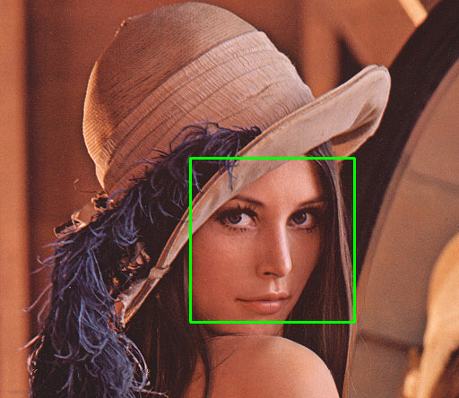

Fig 4.6: Successfully detect the face in an image

**4.2. FACE RECOGNITION:**

Face recognition is a [computer vision](https://www.superannotate.com/blog/introduction-to-computer-vision) application that has played an active role in our lives in one way or another. From something as mundane as recognizing and suggesting which friend to tag on a Facebook image to unlocking our smartphones or other devices at the speed of light — face recognition algorithms make it happen and more. As people, we’re equipped with the skills needed to recognize hundreds of faces and recall who they belong to. Our current developments in technology are what allow us to give digital systems the ability to mimic human processes as accurately as possible.

Before we dive into the inner workings of face recognition software, it’s important to determine what is AI face recognition exactly. Luckily, the term is straightforward and doesn’t leave much open to interpretation — face recognition is the task of detecting a face and identifying a person’s identity from an input visual in a digital system. From the result, we understand whether or not the identity of the person precisely matches anything from an existing database. Modern-day face recognition algorithms give us the capability to carry out that process on an array of visuals — from images to pre-recorded videos and even real-time footage.

The data used during face recognition is referred to as biometric information — similar to that of when software stores information about your fingerprint, iris/retina, or voice. Detecting the presence of a face is relatively simple, but it is the biometric data that is necessary to differentiate and label the billions of faces that exist.

**4.2.1 Face detection vs. face recognition:**

It’s easy to misconceive face detection as face recognition when initially being introduced to the subject. To know the difference between face detection and face recognition, you need a basic understanding of [object detection](https://www.superannotate.com/blog/object-detection-with-deep-learning). With object detection, the primary aim of the task is to note the location of a particular object in a visual, mark its limits with a [bounding box](https://www.superannotate.com/blog/introduction-to-bounding-box-annotation-best-practices), and attach a category to that object. If we merely want to carry out face detection, that same process is applied to detecting faces in a given image or video footage to simply locate the position and boundaries of a face. It will not, however, give us more detailed information, such as if the face belongs to an existing 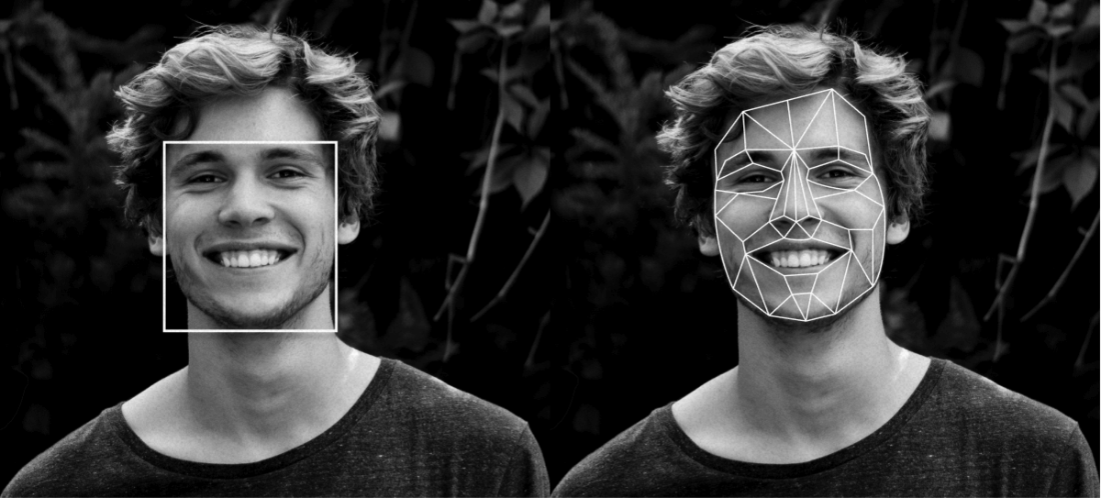database or whose face exactly is detected.

Fig 4.7: Face detection vs. face recognition

You may wonder in which scenarios face detection alone can be resourceful without going a step further to carry out face recognition. As a matter of fact, there are several such circumstances, such as when you need to take a headcount of the people present in a crowd, know whether or not there is a face present, and so on.

**4.2.2 Working of face recognition:**

Now we can determine how to do facial recognition. It’s typically executed through Python since this approach is arguably the quickest. The process of face recognition using machine learning methods follows these five main steps:

Detecting a face:

Remember how we just talked about face detection? Well, it’s a vital first step in the facial recognition process. The machine first needs to detect the face(s) in an image to first establish if there are any faces at all, which will be the source material for the later steps.

Face alignment:

Once a face has been established and detected, the next step is to determine the alignment of the face. One of the drawbacks of current face recognition technology is that the face needs to be clearly shown (free from occlusion, not covered by clothing or other objects) and looking in the direction of the camera to provide a higher probability of accuracy. You can train a machine learning model to detect the key points of a face (chin, eyes, mouth, etc.) and slightly tilt the image to center it in order to get a front-facing alignment.

Face measurement & extraction:

Next, once a face is detected and the primary characteristics of the face are evident from the image, the necessary features for face recognition can be extracted. That includes but is not limited to the measurements of the eyes, nose, mouth, and so on. This step will go on to help find similar matches of the extracted features from the database.

Recognition:

Only then can we execute the actual process of facial recognition. That is when a final algorithm will compare the measurements extracted from the features to the database to search for potential matches.

Verification:

Finally, the facial features can be compared between visuals until a complete match is verified. If an exact match is not found in the database, then the face will remain unverified. Just like any ML system, you must keep in mind that the functionality of the algorithm relies on both the quantity and quality of the training data. You can train the model either with your own data or with the help of open-source datasets.

**4.2.3 Techniques for face recognition:**

While humans can recognize faces without much effort, facial recognition is a challenging [pattern recognition](https://en.wikipedia.org/wiki/Pattern_recognition) problem in [computing](https://en.wikipedia.org/wiki/Computing). Facial recognition systems attempt to identify a human face, which is three-dimensional and changes in appearance with lighting and facial expression, based on its two-dimensional image. To accomplish this computational task, facial recognition systems perform four steps. First [face detection](https://en.wikipedia.org/wiki/Face_detection) is used to segment the face from the image background. In the second step the segmented face image is aligned to account for face [pose](https://en.wikipedia.org/wiki/Pose), image size and photographic properties, such as [illumination](https://en.wikipedia.org/wiki/Illumination_(image)) and [grayscale](https://en.wikipedia.org/wiki/Grayscale). The purpose of the alignment process is to enable the accurate localization of facial features in the third step, the facial feature extraction. Features such as eyes, nose and mouth are pinpointed and measured in the image to represent the face. The so established [feature vector](https://en.wikipedia.org/wiki/Feature_vector) of the face is then, in the fourth step, matched against a database of faces. Traditional

Some face recognition [algorithms](https://en.wikipedia.org/wiki/Algorithms) identify facial features by extracting landmarks, or features, from an image of the subject's face. For example, an algorithm may analyze the relative position, size, and/or shape of the eyes, nose, cheekbones, and jaw. These features are then used to search for other images with matching features.

Other algorithms [normalize](https://en.wikipedia.org/wiki/Normalization_(image_processing)) a gallery of face images and then compress the face data, only saving the data in the image that is useful for face recognition. A probe image is then compared with the face data. One of the earliest successful systems is based on template matching techniques applied to a set of salient facial features, providing a sort of compressed face representation.

Recognition algorithms can be divided into two main approaches: geometric, which looks at distinguishing features, or photo-metric, which is a statistical approach that distills an image into values and compares the values with templates to eliminate variances. Some classify these algorithms into two broad categories: holistic and feature-based models. The former attempts to recognize the face in its entirety while the feature-based subdivide into components such as according to features and analyze each as well as its spatial location with respect to other features.

Popular recognition algorithms include principal component analysis using [eigenfaces](https://en.wikipedia.org/wiki/Eigenface), [linear discriminant analysis](https://en.wikipedia.org/wiki/Linear_discriminant_analysis), [elastic bunch graph matching](https://en.wikipedia.org/wiki/Elastic_matching) using the Fisherface algorithm, the [hidden Markov model](https://en.wikipedia.org/wiki/Hidden_Markov_model), the [multilinear subspace learning](https://en.wikipedia.org/wiki/Multilinear_subspace_learning) using [tensor](https://en.wikipedia.org/wiki/Tensor) representation, and the neuronal motivated [dynamic link matching](https://en.wikipedia.org/wiki/Dynamic_link_matching). Modern facial recognition systems make increasing use of machine learning techniques such as [deep learning](https://en.wikipedia.org/wiki/Deep_learning).

Human identification at a distance (HID):

To enable human identification at a distance (HID) low-resolution images of faces are enhanced using [face hallucination](https://en.wikipedia.org/wiki/Face_hallucination). In [CCTV](https://en.wikipedia.org/wiki/CCTV) imagery faces are often very small. But because facial recognition algorithms that identify and plot facial features require high resolution images, resolution enhancement techniques have been developed to enable facial recognition systems to work with imagery that has been captured in environments with a high [signal-to-noise ratio](https://en.wikipedia.org/wiki/Signal-to-noise_ratio). Face hallucination algorithms that are applied to images prior to those images being submitted to the facial recognition system use example-based machine learning with pixel substitution or [nearest neighbour distribution](https://en.wikipedia.org/wiki/Nearest_neighbour_distribution) indexes that may also incorporate demographic and age related facial characteristics. Use of face hallucination techniques improves the performance of high resolution facial recognition algorithms and may be used to overcome the inherent limitations of super-resolution algorithms. Face hallucination techniques are also used to pre-treat imagery where faces are disguised. Here the disguise, such as sunglasses, is removed and the face hallucination algorithm is applied to the image. Such face hallucination algorithms need to be trained on similar face images with and without disguise. To fill in the area uncovered by removing the disguise, face hallucination algorithms need to correctly map the entire state of the face, which may be not possible due to the momentary facial expression captured in the low resolution image.

3-dimensional recognition:

[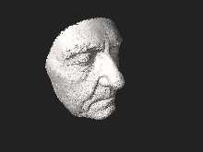](https://en.wikipedia.org/wiki/File:3D_face.stl)

Fig 4.8: 3D model of a human face

[Three-dimensional face recognition](https://en.wikipedia.org/wiki/Three-dimensional_face_recognition) technique uses 3D sensors to capture information about the shape of a face. This information is then used to identify distinctive features on the surface of a face, such as the contour of the eye sockets, nose, and chin. One advantage of 3D face recognition is that it is not affected by changes in lighting like other techniques. It can also identify a face from a range of viewing angles, including a profile view. Three-dimensional data points from a face vastly improve the precision of face recognition. 3D-dimensional face recognition research is enabled by the development of sophisticated sensors that project structured light onto the face. 3D matching technique are sensitive to expressions, therefore researchers at [Technion](https://en.wikipedia.org/wiki/Technion) applied tools from [metric geometry](https://en.wikipedia.org/wiki/Metric_geometry) to treat expressions as [isometries](https://en.wikipedia.org/wiki/Isometries). A new method of capturing 3D images of faces uses three tracking cameras that point at different angles; one camera will be pointing at the front of the subject, second one to the side, and third one at an angle. All these cameras will work together so it can track a subject's face in real-time and be able to face detect and recognize.

[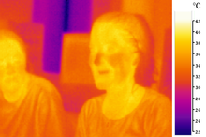](https://en.wikipedia.org/wiki/File:Ir_girl.png)Thermal cameras:

Fig 4.9: Thermal Image of a Human face

A [pseudo color](https://en.wikipedia.org/wiki/False_color) image of two people taken in long-wavelength infrared (body-temperature thermal) light

A different form of taking input data for face recognition is by using [thermal cameras](https://en.wikipedia.org/wiki/Thermographic_camera), by this procedure the cameras will only detect the shape of the head and it will ignore the subject accessories such as glasses, hats, or makeup. Unlike conventional cameras, thermal cameras can capture facial imagery even in low-light and night time conditions without using a flash and exposing the position of the camera. However, the databases for face recognition are limited. Efforts to build databases of thermal face images date back to 2004. By 2016, several databases existed, including the IIITD-PSE and the Notre Dame thermal face database. Current thermal face recognition systems are not able to reliably detect a face in a thermal image that has been taken of an outdoor environment.

In 2018, researchers from the [U.S. Army Research Laboratory (ARL)](https://en.wikipedia.org/wiki/United_States_Army_Research_Laboratory) developed a technique that would allow them to match facial imagery obtained using a thermal camera with those in databases that were captured using a conventional camera. Known as a cross-spectrum synthesis method due to how it bridges facial recognition from two different imaging modalities, this method synthesizes a single image by analysing multiple facial regions and details. It consists of a non-linear regression model that maps a specific thermal image into a corresponding visible facial image and an optimization issue that projects the latent projection back into the image space. ARL scientists have noted that the approach works by combining global information (i.e. features across the entire face) with local information (i.e. features regarding the eyes, nose, and mouth). According to performance tests conducted at ARL, the multi-region cross-spectrum synthesis model demonstrated a performance improvement of about 30% over baseline methods and about 5% over state-of-the-art methods.

**4.2.4 Use cases and applications:**

As we’ve established, facial recognition software exists all around us, and the applications are essentially uncountable. With that said, let’s take a look at a few of the most prominent facial recognition applications that are paving the path to a safer and more efficient future.

Device & access security:

If we only imagine exciting scenes like a person unlocking a secret lair with a face scanner in old spy movies, now, technology like that is accessible in the palms of everyone’s hands. From smartphones to tablets and smart vehicles, face recognition software allows us to limit who has access to our devices to maintain privacy. Whole vehicles and rooms can also require facial authorization to only allow owners access to private property.

Shoplifting & crime:

People who manage to shoplift once won’t have much luck a second time around if the store is equipped with facial recognition [security](https://www.superannotate.com/blog/computer-vision-in-security-and-surveillance) measures to compare the flow of shoppers to shoplifters from their database. In many cases, if a direct match is detected, it can trigger nearby police or security to detain the criminal on the spot. This can be expanded to all types of stores and institutions, including the help of local police to handle criminal activity in the area efficiently.

Border control:

If you’ve crossed an international border before, then it should come as no surprise that a face scan is done during border control to track immigration and prohibit the entry of criminals. The faces are scanned and run through a database before a person is “cleared” to cross the border. This makes for easier, quicker, and more effective tracking of national security.

Hospitals & assisted living:

Tech-forward medical institutions and assisted living centers are rolling out cameras equipped with facial recognition as a security measure. They can help keep track of patients who wander off and ensure no patient is left unaccounted for. This can also aid in detecting strangers that somehow make their way into the facility.

Social media:

Founded in 2013, [Looksery](https://en.wikipedia.org/wiki/Looksery) went on to raise money for its face modification app on Kickstarter. After successful crowdfunding, [Looksery](https://en.wikipedia.org/wiki/Looksery) launched in October 2014. The application allows video chat with others through a special filter for faces that modifies the look of users. [Image augmenting](https://en.wikipedia.org/wiki/Augmented_reality) applications already on the market, such as [Facetune](https://en.wikipedia.org/wiki/Facetune) and Perfect365, were limited to static images, whereas Looksery allowed augmented reality to live videos. In late 2015 [SnapChat](https://en.wikipedia.org/wiki/Snap_Inc.) purchased Looksery, which would then become its landmark lenses function. Snapchat filter applications use face detection technology and on the basis of the facial features identified in an image a 3D mesh mask is layered over the face.

[DeepFace](https://en.wikipedia.org/wiki/DeepFace) is a [deep learning](https://en.wikipedia.org/wiki/Deep_learning) facial recognition system created by a research group at [Facebook](https://en.wikipedia.org/wiki/Facebook,_Inc.). It identifies human faces in digital images. It employs a nine-layer [neural net](https://en.wikipedia.org/wiki/Neural_net) with over 120 million connection weights, and was [trained](https://en.wikipedia.org/wiki/Machine_learning) on four million images uploaded by Facebook users. The system is said to be 97% accurate, compared to 85% for the FBI's [Next Generation Identification](https://en.wikipedia.org/wiki/Next_Generation_Identification) system.

[TikTok](https://en.wikipedia.org/wiki/TikTok)'s algorithm has been regarded as especially effective, but many were left to wonder at the exact programming that caused the app to be so effective in guessing the user's desired content. In June 2020, TikTok released a statement regarding the "For You" page, and how they recommended videos to users, which did not include facial recognition. In February 2021, however, TikTok agreed to a $92 million settlement to a US lawsuit which alleged that the app had used facial recognition in both user videos and its algorithm to identify age, gender and ethnicity.

ID verification:

The emerging use of facial recognition is in the use of [ID verification services](https://en.wikipedia.org/wiki/ID_verification_service). Many companies and others are working in the market now to provide these services to banks, ICOs, and other e-businesses. Face recognition has been leveraged as a form of biometric [authentication](https://en.wikipedia.org/wiki/Authentication) for various computing platforms and devices, [Android 4.0 "Ice Cream Sandwich"](https://en.wikipedia.org/wiki/Android_Ice_Cream_Sandwich) added facial recognition using a [smartphone](https://en.wikipedia.org/wiki/Smartphone)'s front camera as a means of [unlocking](https://en.wikipedia.org/wiki/Lock_screen) devices, while [Microsoft](https://en.wikipedia.org/wiki/Microsoft) introduced face recognition login to its [Xbox 360](https://en.wikipedia.org/wiki/Xbox_360) video game console through its [Kinect](https://en.wikipedia.org/wiki/Kinect) accessory, as well as [Windows 10](https://en.wikipedia.org/wiki/Windows_10) via its "Windows Hello" platform (which requires an infrared-illuminated camera). In 2017, Apple's [iPhone X](https://en.wikipedia.org/wiki/IPhone_X) smartphone introduced facial recognition to the product line with its "[Face ID](https://en.wikipedia.org/wiki/Face_ID)" platform, which uses an infrared illumination system.

Face ID:

[Apple](https://en.wikipedia.org/wiki/Apple_Inc.) introduced [Face ID](https://en.wikipedia.org/wiki/Face_ID) on the flagship iPhone X as a biometric authentication successor to the [Touch ID](https://en.wikipedia.org/wiki/Touch_ID), a [fingerprint](https://en.wikipedia.org/wiki/Fingerprint) based system. Face ID has a facial recognition sensor that consists of two parts: a "Romeo" module that projects more than 30,000 infrared dots onto the user's face, and a "Juliet" module that reads the pattern. The pattern is sent to a local "Secure Enclave" in the device's [central processing unit](https://en.wikipedia.org/wiki/Central_processing_unit) (CPU) to confirm a match with the phone owner's face.

The facial pattern is not accessible by Apple. The system will not work with eyes closed, in an effort to prevent unauthorized access. The technology learns from changes in a user's appearance, and therefore works with hats, scarves, glasses, and many sunglasses, beard and makeup. It also works in the dark. This is done by using a "Flood Illuminator", which is a dedicated [infrared](https://en.wikipedia.org/wiki/Infrared) flash that throws out invisible infrared light onto the user's face to properly read the 30,000 facial points.

Healthcare:

Facial recognition algorithms can [help in diagnosing](https://en.wikipedia.org/wiki/Computer-aided_diagnosis) some diseases using specific features on the nose, cheeks and other part of the [human face](https://en.wikipedia.org/wiki/Face). Relying on developed data sets, machine learning has been used to identify genetic abnormalities just based on facial dimensions. FRT has also been used to verify patients before surgery procedures.

**CHAPTER – 5**

**PROPOSED METHODOLOGY**

**5.1 INTRODUCTION:**

The main aim of the project is to simplify the conventional attendance marking system and to achieve higher accuracy while recognition and identification of faces. This can be achieved by using KNN (k-nearest neighbors) algorithm.

The management of the attendance can be a great burden on the teachers if it is done by hand. To resolve this problem, smart and auto attendance management system is being utilized. But authentication is an important issue in this system. The smart attendance system is generally executed with the help of biometrics.

Face recognition is one of the biometric methods to improve this system. Being a prime feature of biometric verification, facial recognition is being used enormously in several such applications, like video monitoring and CCTV footage system, an interaction between computer & humans and access systems present indoors and network security

**ALGORITHM**

**IMAGE CAPTURE**

**IMAGE PROCESSING**

**RECORD ATTENDENCE**

**POST ATTENDENCE**

**UPDATE STORED ATTENDANCE**

**NO**

**YES**

**CLASS END**

Fig 5.1: Workflow of Algorithm

**5.2 WORKING OF KNN:**

K Nearest Neighbor(KNN) algorithm is a very simple, easy to understand, versatile and one of the topmost machine learning algorithms. In k-NN classification, the output is a class membership. An object is classified by a plurality vote of its neighbours, with the object being assigned to the class most common among its k nearest neighbours (k is a positive integer, typically small). If k = 1, then the object is simply assigned to the class of that single nearest neighbour.

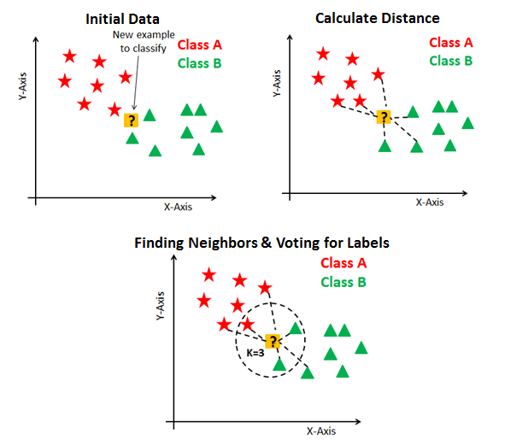In KNN, K is the number of nearest neighbours. The number of neighbours is the core deciding factor. K is generally an odd number if the number of classes is 2. When K=1, then the algorithm is known as the nearest neighbour algorithm. This is the simplest case.  
Suppose P1 is the point, for which label needs to be predicted.

Fig 5.2: Basic steps in KNN.

KNN has three basic steps.  
1. Calculate the distance.  
2. Find the k nearest neighbours.  
3. Vote for classes

Importance of K

You can’t pick any random value for k. The whole algorithm is based on the k value. Even small changes to k may result in big changes. Like most machine learning algorithms, the K in KNN is a hyperparameter. You can think of K as a controlling variable for the prediction model

**5.2.1 KNN for Face Recognition:**

The in-built face-recognition module in python detects the crucial face points.

These locations and the distance between them is noted and these are different for each individual’s face.

These values are given to a KNN (k-nearest neighbors) algorithm for training

The face of an individual is identified by using the trained model it selects the nearest neighbor for the facial points and shows the result.

**5.3 KNN ALGORITHM TRAINING:**

Data Gathering:

The images of the students will be captured and stored in a file hierarchy as per the requirements for the algorithm training purpose.

Algorithm Training:

The algorithm need to be trained with the captured images such that it yields maximum accuracy. The trained model is saved to the given path so that we can use it for prediction purpose

**5.4 PREDICTION**

Face Detection:

Faces are detected from the image captured during class.

Face identification:

Faces detected are identified by using the pre-trained KNN model.

Naming Faces/Marking attendance:

Detected faces will be named by the person’s name and used for marking attendance.

**5.5 TRAINED ALGORITHM WORKING:**

Image capturing:

Image will be captured by the available camera devices .

Image processing:

The captured image will be processed and the human faces in the image will be detected by using haar-features.

Algorithm:

The faces detected will be given to the algorithm part and the faces will be identified by using pre-trained KNN model

Then the attendance will be recorded from that image and the images will be taken till the end of the class. The students who are identified in those images will be recorded as attendees for the respective class.

**CHAPTER – 6**

**RESULTS**

Dataset Images Folder:

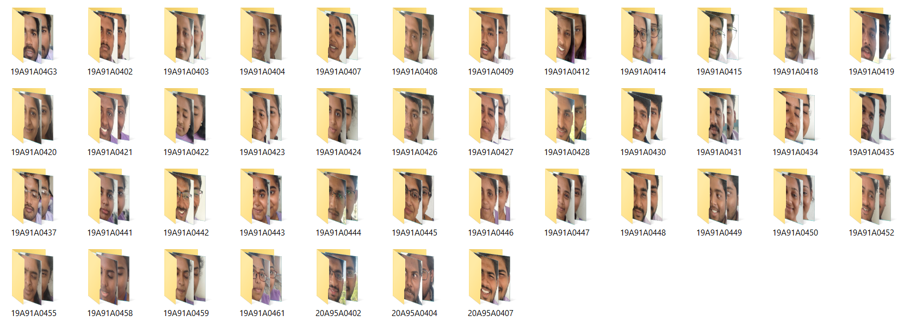

Fig 6.1: Database Folder

Images for the training purpose are stored in the database folder with their respective roll number folders as shown in Fig 6.1

Dataset Images:



Fig 6.2: Images of students from database

Testing and output images:

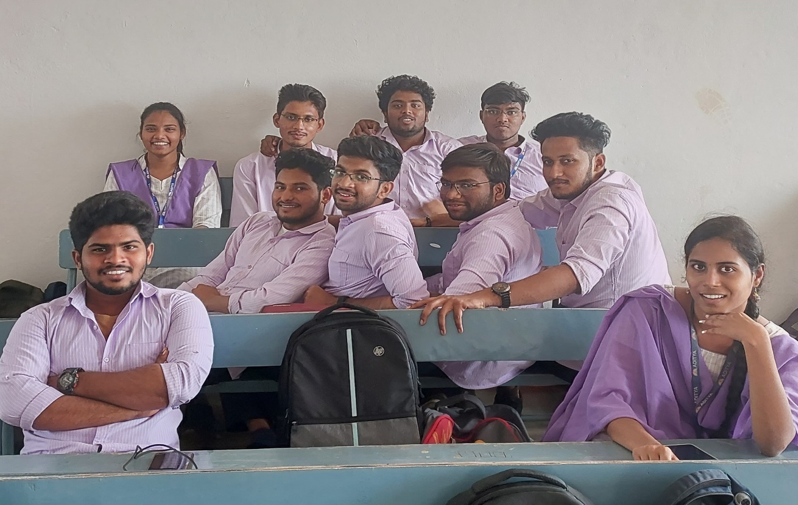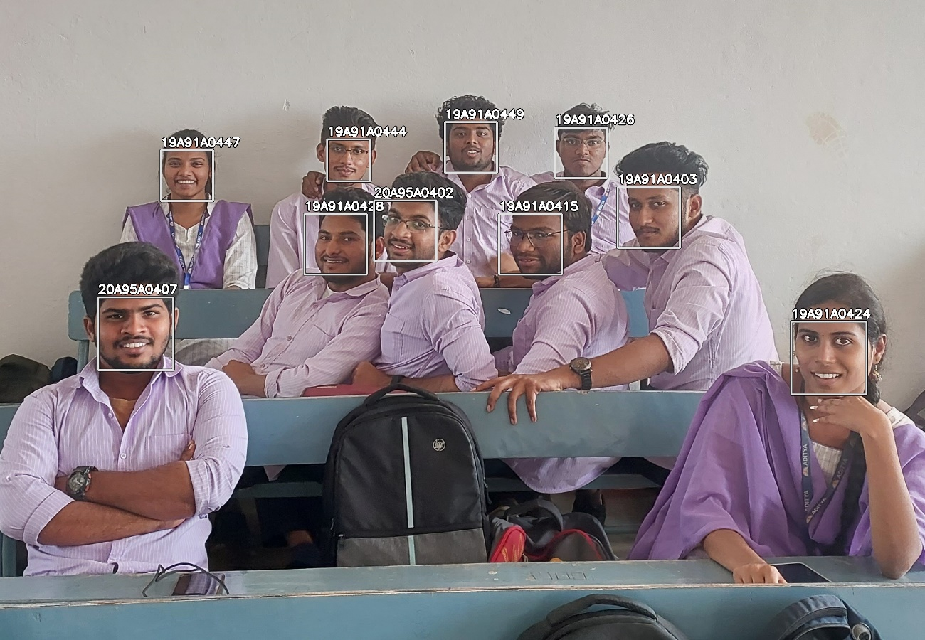

Fig 6.3: Testing Image -1

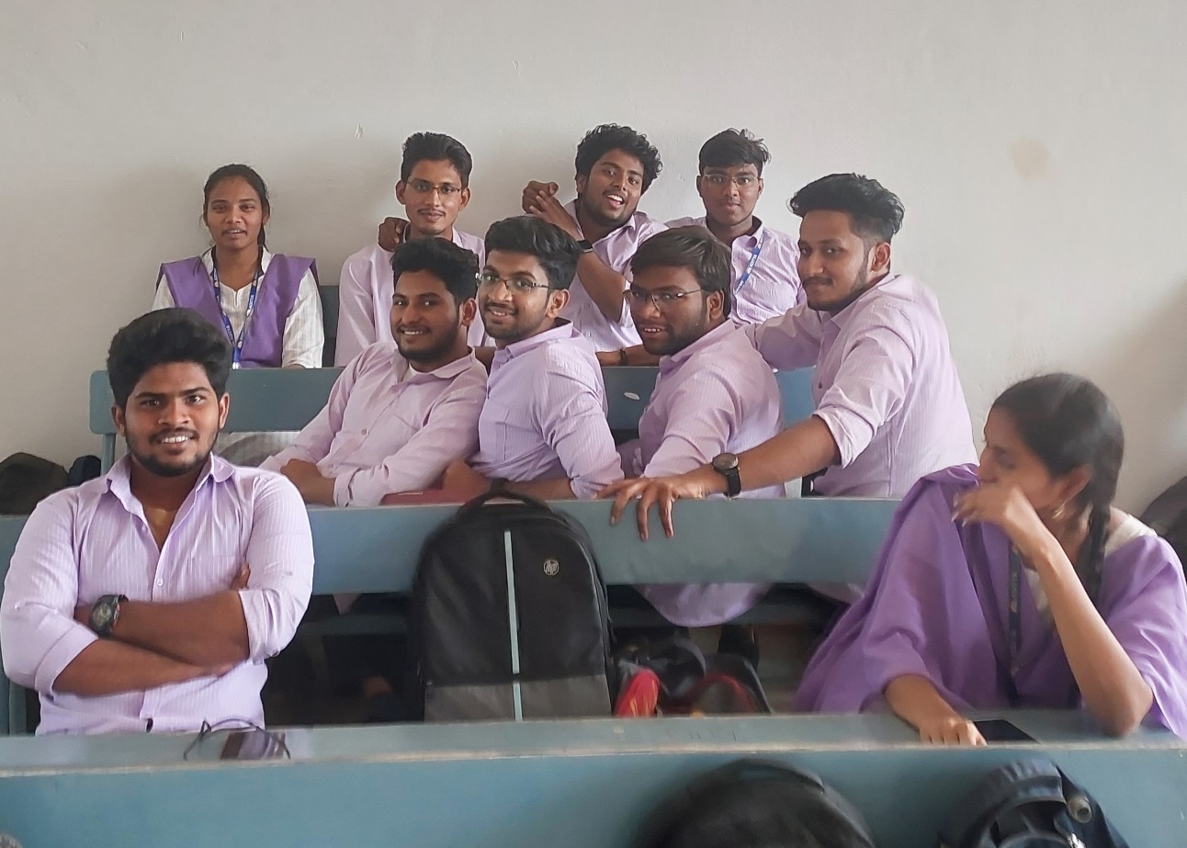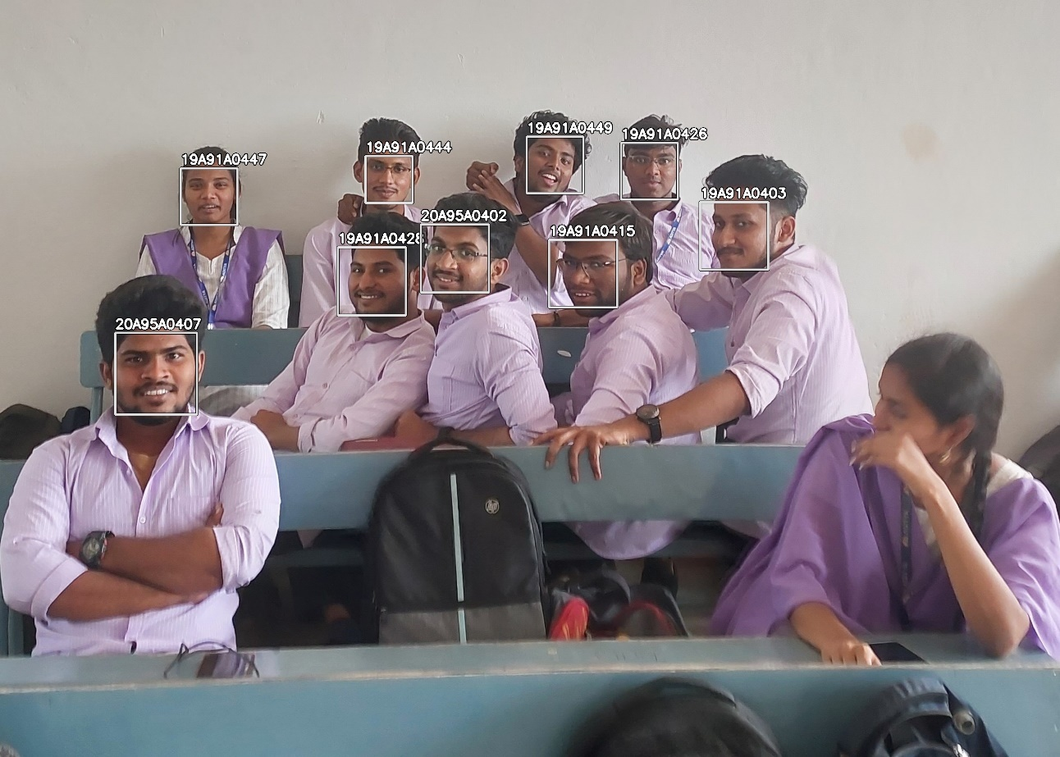

Fig 6.4: Testing Image - 2

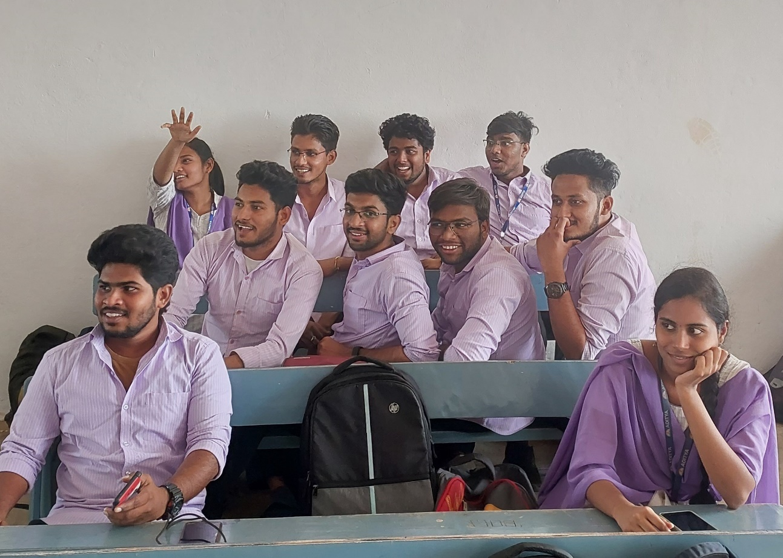

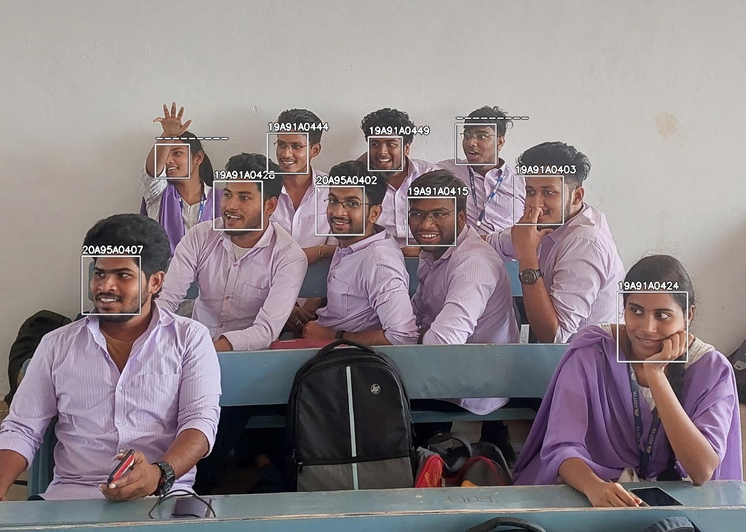

Fig 6.5: Testing Image - 3

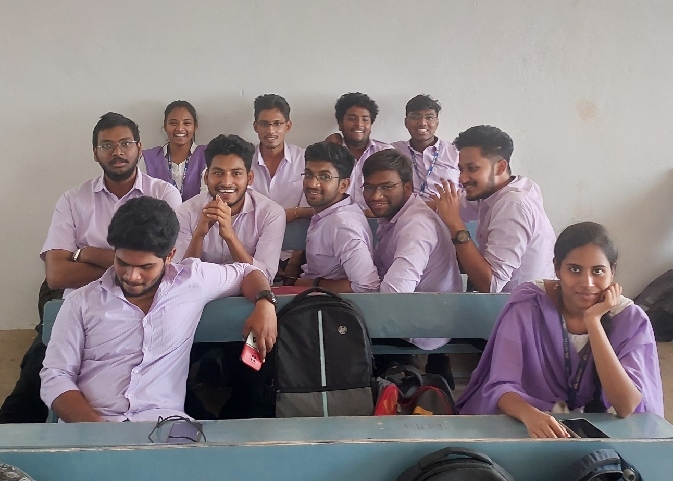

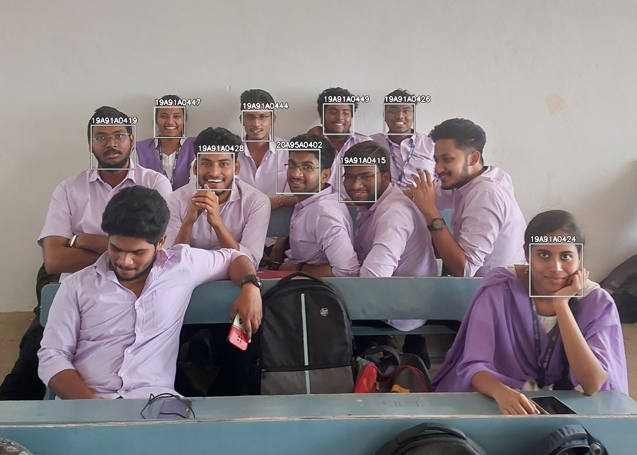

Fig 6.6: Testing Image - 4

Images that are taken in classroom are given as input images for prediction algorithm and the output will be shown in two different ways

* Roll numbers on the detected face in the output images.
* Roll numbers of the students detected from all images in single excel file.

Output Excel file:

The total attendance output from the images are stored in the excel sheet.

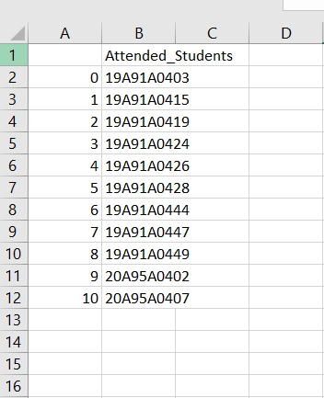

Fig 6.7: Attendance in excel sheet

**CHAPTER – 7**

**CONCLUSION AND FUTURE SCOPE**

**Conclusion:**

First, a group photograph is taken from which individual faces are then extracted using a face-recognition module and identified using the KNN (k-nearest neighbours) algorithm. Up until the end of class, images are still being taken. After each student has been identified, the attendance will be posted at the end of the lesson. To produce more reliable findings, the database can be updated annually.

If the taken image and the image in the database match, or if both images are the same, AAT records individual attendance. The suggested method reduces effort, records daily management activities for each student, and streamlines the presence marking process.

**Future Scope:**

This project can be further developed by posting the attendance directly into attendance portal after the class and also can be implemented by using a CCTV monitoring.

**REFERENCES**

[1] “Classroom Attendance Monitoring Using CCTV” Manakula Vinayagar Institute of Technology, Madagadipet, Puducherry, India, IEEE ICSCAN 2020

[2] “An Image Acquisition Method for Face Recognition and Implementation of an Automatic Attendance System for Events” Universidad Peruana de Ciencias Aplicadas Lima, Peru, 2019 IEEE

[3] “An Event Driven Attendance Tracker” R. F. Kurdi College of Engineering, Effat University, Jeddah, KSA,2018 IEEE

[4] “Real-Time Smart Attendance System using Face Recognition Techniques” , Amity University Uttar Pradesh, Noida, 2019 IEEE

[5] “Smart Digital Monitoring for Attendance System”, International Conference on Recent Innovations in Electrical, Electronics & Communication Engineering - (ICRIEECE), 2018 IEEE

[6] “Comparison Of Various Face Recognition Algorithms” International Journal of Advanced Research in Science, Engineering and Technology Vol. 4, Issue 2 , February 2017

 [7] “LBPH-Based Enhanced Real Time Face Recognition “International Journal of Advanced Computer Science and Applications Vol.10, No. 5, Published in 2019.

[8] ” Face Detection using LBP Features”Jo Chang-yeon CS 229 Final Project Report December 12 ,2008.

[9] “Face Recognition System Based on LBPH Algorithm”, International Journal of Engineering & advanced technology(IJEAT),Volume-8,Issue5S,May,2019.

[10] Himanshu Tiwari1“Live Attendance System via Face Recognition” International Journal for Research in Applied Science & Engineering Technology (IJRASET) Volume 6 Issue IV, April 2018.

[11] “Face Recognition Technique Using ICA and LBPH”, Khusbu Rani1, Sukhbir , kamboj2,IRJET,Volume-04,issu08,August-2017

[12] E.Varadharajan, R.Dharani, S.Jeevitha, B.Kavinmathi, S.Hemalatha,Automatic attendance management system using face detection, Online International Conference on Green Engineering and Technologies (IC-GET), 978-1-5090-4556-3/16/$31.00 ©2016 IEEE.

[13] Naveed Khan Balcoh, M.HaroonYousaf, Waqar Ahma nd M.IramBaig, Algorithm for efficient Attendance Management: FaceRecognition Based approach, International Journal of Computer Science Issue, Vol.9, Issue 4, No 1, July 2012.

[14] An Accurate System for Face Detection and Recognition Abdelmgeid A. Ali1, Tarek Abd El-Hafeez and Yosra Khalaf Mohany Journal of Advances in Mathematics and Computer Science33(3): 1-19, 2019; Article no.JAMCS.49994 ISSN: 2456-9968 tems and Applications (ICEDSA), 2016 5th International Conference on, pp. 1-4. IEEE, 201

[15] C. G. Tredoux, Y. Rosenthal, L. d. Costa, and D. Nunez, Face reconstruction using a configural, eigenface-based composite system, in 3rd Biennial Meeting of the Society for Applied Research in Memory and Cognition (SARMAC). Boulder, Colorado, USA, 1999.

[16] K. Balci and V. Atalay, PCA for Gender Estimation: Which Eigenvectors Contribute? in Proceedings of Sixteenth International Conference on Pattern Recognition, Vol.3. Quebec City, Canada, 2002, pp. 363-366.

[17] B. Moghaddam and M. H. Yang, Learning Gender with Support Faces, IEEE Transactions on Pattern Analysis and Machine Intelligence, Vol.24, pp.707-711, 2002.

[18] R. Brunelli and T. Poggio, HyperBF Networks for Gender Classification, Proceedings of DARPA Image Understanding Workshop, pp.311-314, 1992.

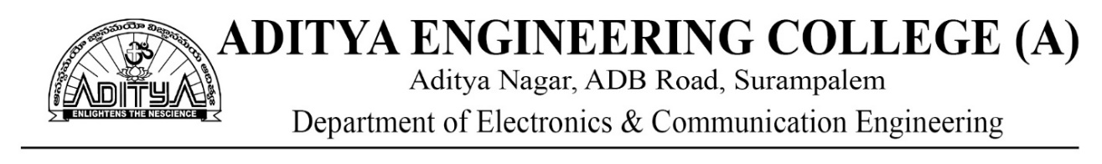

Academic Year: 2022-23

Project Title: **Automatic Attendance Tracing Using Image Processing in Python**

Type of Project: Societal oriented

Project Guide: Mr. A. Kondababu

|  |  |  |  |
| --- | --- | --- | --- |
| **PROGRAM OUTCOMES** | | | |
| PO1 | Engineering knowledge | PO7 | Environment and sustainability |
| PO2 | Problem analysis | PO8 | Ethics |
| PO3 | Design/development of solutions | PO9 | Individual and team work |
| PO4 | Conduct investigations of complex problems | PO10 | Communication |
| PO5 | Modern tool usage | PO11 | Project management and finance |
| PO6 | The engineer and society | PO12 | Lifelong learning |

|  |  |
| --- | --- |
| **PROGRAM SPECIFIC OUTCOMES** | |
| PSO1 | Provide sustainable solutions in the field of Communication and Signal Processing. |
| PSO2 | Apply current technologies in the field of VLSI and embedded systems for professional  growth. |

**CONCLUSION STATEMENTS**

|  |  |  |  |
| --- | --- | --- | --- |
| **S.No** | **Description** | **Attained COs** | **Attained POs/PSOs** |
| 1 | Identified manual attendance tracking systems and their problems. | CO1 | PO1 |
| 2 | Analysed the problems encountered in attendance recording. | CO1, CO2 | PO2,  PO4, PO5,  PO9 |
| 3 | Researched about ways to detect and identify face for automatic attendance. | CO3, CO6 | PO2, PSO1 |
| 4 | Literatures were reviewed about classroom attendance using image processing from various authors. | CO2 | PO2 |
| 5 | A new method for Automatic attendance tracing is proposed. | CO2, CO3 | PO3, PO5,  PO8 |
| 6 | Compared this method with existing methods. | CO2 | PO4, PO12 |
| 7 | New techniques were added to make a new and better solution for the problem. | CO5, CO7, CO8 | PO3, PO6, PO8, PSO1 |
| 8 | Concluded and analysed the solution and presented it. | CO2, CO4  CO5, CO9  C010 | PO9, PO10.  PO11 |

**Signature of the Team members**

P. Mehar Srinivas Chowdari (19A91A0437)

R. Suresh (19A91A0442)

N. Adithya (19A91A0431)

**STUDENT DETAILS**

1. Roll number : 19A91A0437

Name of the student : PUTTA MEHAR SRINIVAS CHOWDARI

Phone Number : 9959273413

Mail ID : [19A91A0437@aec.edu.in](mailto:19A91A0437@aec.edu.in)

1. Roll number : 19A91A0442

Name of the student : REPAKA SURESH

Phone Number : 7981775777

Mail ID : [19A91A0442@aec.edu.in](mailto:19A91A0442@aec.edu.in)

1. Roll number : 19A91A0431

Name of the student : NALABAI ADITHYA

Phone Number : 9014247789

Mail ID : [19A91A0431@aec.edu.in](mailto:19A91A0431@aec.edu.in)